

**Artificial Intelligence (AI) – Cover Sheet**

GROUP ASSIGNMENT

**Instruction:**

• Marks will be awarded for good presentation and thoroughness in your approach.

• Referencing Code: If you use some code, or ideas for code, which are taken or adapted from another source (book, magazine, internet, discussion forum, etc), then this **must** be cited and referenced using the Harvard Name convention within your source code. Failure to reference code properly is considered as plagiarism.

• Complete this cover sheet and attach it to your project.

* This project is to be attempted by a group of 3 or 4 students.

|  |  |  |
| --- | --- | --- |
| **Student declaration:** | | |
| *I declare that:* | 1. *We understand what is meant by plagiarism* 2. *The implication of plagiarism has been explained to us by our lecturer* 3. *This project is all our work and we have acknowledged any use of the published or unpublished works of other people.* | |
| Group Leader’s Signature: | | Date: |

|  |  |  |  |  |
| --- | --- | --- | --- | --- |
| **Project Title:** | | **Sunway Technical Medical Centre** | **Intake: APD1F2011CS(IS)/** **APU1F2011CS** | |
| **Role** | **Name** | | | **Signature** |
| **Team Leader** | **Eslam Magdy Rezk Ebrahim Hassanin** | | |  |
| **Knowledge**  **Engineer** | **Ali Abdulameer Abdali Abdulla Alsheala** | | |  |
| **Knowledge**  **Engineer** | **Nurfarah Hafina binti Mohamad Nizam** | | |  |
| **Knowledge**  **Engineer** | **Adryana Marzookhy Binti Azhar** | | |  |

# **Abstract (300 Word):**

Introduction about the Expert System:

Sunway Private Medical Center is one of the most important centers in Malaysia (sunwaymedical, n.d.) and has many medical departments. Some students prepared research to create an expert system that helps patients in some of their cases.

Purpose of the assignment:

The purpose is to apply the idea of ​​the expert system to the Sunway Medical Center to help patients and provide them with the necessary information about their disease and reduce the mistakes made by the patient through his lack of information about diseases and help the doctors who work in the medical center because in the future, if this idea succeeds, it will be circulated in many areas.

Brief explanation of the proposed chatbot application:

The chatbot is distinguished by helping the patient of the Sunway Medical Center and has been applied to four problems to solve Mental illness depression, Pregnancy, Bipolar disorder, and The Coronary Artery Disease, by giving the necessary advice and instructions, diet and disease prevention, what are the side effects of these problems, the medicines used under medical advice, comprehensive information about the nature of these cases, as well as frequently asked questions about the nature of these cases. Also, this system for novice users, which leads users to have a lot of questions and an expert system will be able to answer them. It will also be a great opportunity for novice and intermediate users, especially novice users, to learn and use an expert system since they do not have much experience with one.

Table of Contents

Abstract (300 Word): 2

1. Problem Specification: 5

**1.1** **Problem Statement:** 5

**1.2** **Benefits of the proposed solution**: 8

2. Knowledge Acquisition: 9

**2.1** **Expert System:** 9

**2.2** **Chatbot Application Review (individual task):** 16

3. Knowledge Representation: 31

**3.1** **Overview of the semantic net:** 31

**3.2** **Diagram of the semantic network:** 31

4. Implementation: 32

**4.1** **Screenshot on the special features:** 32

**4.2** **User Acceptance Testing (Survey):** 37

**4.3** **Result of the user Acceptance:** 44

5. Conclusion: 59

**5.1** **Challenges:** 59

**5.2** **Future Enhancement:** 61

References 62

Appendices 64

• Source codes of the chatbot: 64

• Workload Matrix: 64

**Table of Figures**

Figure 1: How to detect the depression by AI (Aitskadapa, n.d.) 6

[Figure 2: How the chatbot works for depression patients works (Baumeistera, 2019) 10](https://cloudmails-my.sharepoint.com/personal/tp062816_mail_apu_edu_my/Documents/IAI%20ASSIGNMENT.docx#_Toc80380204)

Figure 3: How the chatbot works 13

Figure 4: Sample 16

Figure 5: Replika Screeshot 1 20

[Figure 6: Replika Screenshot 2 20](https://cloudmails-my.sharepoint.com/personal/tp062816_mail_apu_edu_my/Documents/IAI%20ASSIGNMENT.docx#_Toc80380208)

Figure 7: Replika screenshot 3 21

Figure 8: Example for Mental illness depression chatbot review 23

Figure 9: Dr.Joy chatbot review 25

Figure 10: hipmunk chatbot review 26

Figure 11: hipmunk chatbot review 26

Figure 12: Doctor chatbot review 29

Figure 13: Doctor chatbot screeshot 1 30

Figure 14: Doctor chatbot report 30

Figure 15:Doctor chatbot screenshotc 3 31

Figure 16: Semantic net diagram 33

Figure 16: Sunway chatbot 1 34

Figure 17:Sunway chatbot 2 35

Figure 18:Sunway chatbot 3 35

Figure 19:Sunway chatbot Notepad 4 36

Figure 20:Sunway chatbot 5 36

Figure 21:Sunway chatbot 6 37

Figure 22:questionnaire 1 39

Figure 23:questionnaire 2 39

Figure 24: questionnaire 3 40

Figure 25:questionnaire 4 40

Figure 26:questionnaire 5 40

Figure 27: Mental illness depression chatbot user acceptance testing survey 41

Figure 28: Mental illness depression chatbot user acceptance testing survey 42

Figure 29: questionnaire 6 42

Figure 30: questionnaire 7 43

Figure 31:questionnaire 8 43

Figure 32:questionnaire 9 43

Figure 33: questionnaire 10 44

Figure 34:questionnaire 11 44

Figure 35: questionnaire 12 44

Figure 36: questionnaire 13 45

Figure 37: questionnaire 14 45

Figure 38: questionnaire 15 45

Figure 39 bipolar disorder chatbot user survey 46

Figure 40 bipolar disorder chatbot user survey 47

Figure 41: User acceptance (Suitable Age) 48

Figure 42: User acceptance (Information and research effort) 49

Figure 43: User acceptance (User-friendly) 50

Figure 44: User acceptance (Online platforms) 51

Figure 45: User acceptance (games/quiz) 52

Figure 46: User acceptance (NLU) 53

Figure 47: User acceptance (Validation) 54

Figure 48: User acceptance (Patient and researchers) 55

Figure 49: User acceptance (Difficulty while using pregnancy chatbot) 56

Figure 50: User acceptance (Sufficient of chatbot) 56

Figure 51: User acceptance (Helping chatbot) 57

Figure 52: User acceptance (Rate of pregnancy) 57

Figure 53:User acceptance (Range of user) 58

Figure 54: User acceptance (User friendly) 58

Figure 55:User acceptance (Useful information) 59

Figure 56: User acceptance (Recommending) 59

Figure 57:User acceptance (Assistance) 60

Figure 58:User acceptance (Helping researcher) 60

Figure 59 User acceptance (Chatbot experience) 61

Figure 60 User acceptance (User-friendly) 61

Figure 61 User acceptance (Info) 62

Figure 62 User acceptance (diagnosis) 62

Figure 63 User acceptance (Recommendation) 63

Figure : User acceptance (Future and chatbot for heart disease) 64

Figure : User acceptance (Useful chatbot for heart disease) 64

Figure : User acceptance (AI and Surgery) 65

Figure : Figure 54: User acceptance (Crisis and chatbot) 65

Figure : Figure 54: User acceptance (Chatbot insteadof doctor) 66

# **Problem Specification:**

## **Problem Statement:**

**First Problem (Mental illness depression):**

Depression patients may need a lot of facilities in hospitals or clinics, so the programmers in our team created a chat bot to help patients in their treatment or refer them to, and so the idea was based on an important basis, which is the problems of patients in general, so for every patient who feels anger, headache, or some illness, patients feel depressed, So, there are many of symptoms of depression, such as:

* **Low mood:**

the low mood must be present for more than two weeks, and this is one of the main symptoms, and not at all that if an important person in his life loses and suffers some sadness, this is evidence of depression, absolutely, the person at that time deals with sadness that lasts for a short period and not depression (Angers, 2020).

* **Anhedonia and loss of interest:**

Symptoms of loss of interest or pleasure will be present in abundance, especially in children and adolescents, and they feel a lot of sleep, loss of appetite, going to university or school, going to drink alcohol, and any one of them may harm himself or lead to successive suicides among young people, especially adolescents (Mayoclinic, n.d.).

Therefore, this purpose has been worked on through artificial intelligence, which is especially important for depression patients, because it will determine what the patient likes or hates or his mood. The patient may find much more privacy than anywhere else, Also, conversations and communications between patients and the program are falsified, they can talk with the program and can also give them feelings that improve their psychological state through an emotional connection between the user and the program to be able to reach rural areas, Also, as we said is not discovering identity and fear of stigma that affects depressed people who suffer from the disease, by not revealing their identity and access to full information about the disease and how to treat it without the need to reveal their faces or talk to anyone (Clarke, 2020).

There are studies conducted by researchers at the University of Stevens that many depressed patients talk about sadness on a continuous basis, and some applications can determine this texts that they write or say by patients through artificial intelligence (stevens, 2021).

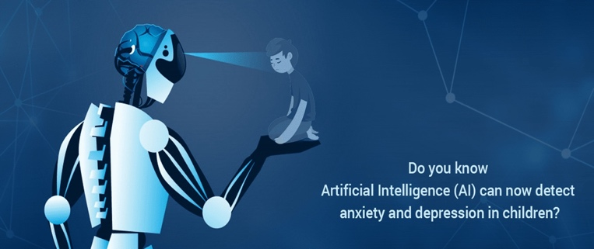

Figure 1: How to detect the depression by AI (Aitskadapa, n.d.)

After that, the chatbot for depression patients is characterized by:

* **Identifying symptoms of depression:**

The patient can know through the chatbot what are the symptoms of depression and whether he suffers from it or not through a conversation between him and the chatbot.

* **Improving the patient's condition:**

The soul of the depressed patient is strengthened by speaking good words in the conversation, not being intimidated by the disease and reducing his psychological state.

* **Provide the patient with the necessary information:**

Giving him information about depression, the benefits and harms of his treatment.

* **Maintaining confidentiality for depressed patients:**

The application is characterized by maintaining the patient's privacy and beliefs, which relieves him of his nerves and psyche.

* **Flexibility with the user and respond in any circumstance:**

The chatbot is more flexible with the user and responds to him in all the things that revolve in his mind related to the disease with some conversations outside the scope of the topic.

**Second Problem (Pregnancy):**

Pregnancy and childbirth where mothers bring new life to the world are two very important events to every mothers . Different pregnant experience and go through different vary experiences to other pregnancy. Most mothers depend on information from known friends or relatives that have experienced the nature of pregnancy. Thus, the experience that pregnant women face vary from one pregnancy to another . There are vast and many information available online and books, yet, it is still very complex and lengthy for applications to provide customized information. So, the programmers from our team created an Artificial Intelligence (AI) chatbot and believe that it can help perinatal women in so many ways and aspects. AI chatbots are able to help mothers to gain factual information and are able to give recommendations and advises to improve their lifestyle to ensure that both fetus ad patients are safe and healthy.

During pregnancy, there are many actions that can be very harmful for both pregnant woman and the fetus such as lack of awareness to conduct health checks during pregnant. Normally, pregnant women ignore any symptoms and signs that shows danger due to busy life and shortage of time, feeling stressed and anxious to confront the problems during pregnancy, lack of interaction between women and healthcare provider, fail to differentiate between correct and incorrect information and having problems to access to various resources to gain information.

**Third Problem (bipolar disorder):**

Over the last decade, there has been a growing increase in the number of bipolar disorder patients. According to (Solé, 2017) the bipolar disorder is the foremost global disability whose biological causes are unknown to this day and the treatment methods are still to this modern time lacking in results. The statistics show that 2.8 percent of U.S. adults have been diagnosed with this disorder (Holland & Nicholls, 2018).

Bipolar disorder is defined by many as a mental disorder that causes mood swings and extreme shifts in energy and activity level. Bipolar disorder which was formerly called manic-depressive illness is recognized into three types Bipolar I, Bipolar II, and Cyclothymic disorders which differ between the duration and the intensity of the manic episodes (Holland & Nicholls, 2018).

In recent years the diagnosis of bipolar disorder was usually confused by other disorders, however, with the development of the mental disorders’ diagnosis field, it became easier to identify the signs and symptoms of bipolar disorder such as Mania, Hypomania, and Major depressive episodes (Jennifer Casarella, 2020).

**Fourth Problem (The Coronary Artery Disease):**

The coronary arteries are the veins that convey blood to your heart. It is the straiten or obstruction of the coronary arteries. The most common cause is typically atherosclerosis. Inside the body, plagues are cholesterol and fatty deposits that have built up inside the arteries. These maladies can obstruct the courses or harm the conduits, which cutoff points or stops blood stream to the heart muscle. In the event that the heart does not get sufficient blood, it cannot get the oxygen and supplements it needs to work appropriately. This can cause chest torment or a cardiovascular failure

One of the issues is that doctors in hospitals or any other medical setting that treats coronary artery disease or other comparable disorders are unable to adequately diagnose patients because they do not have all of the necessary information at the time of diagnosis. Aside from that, it takes a lot of time and effort for doctors to continue to apply procedures like Interviews, questionnaires, and other methods are used.

## **Benefits of the proposed solution**:

Instead of using traditional procedures like interviews and questionnaires, the expert system will be able to transfer the knowledge of human experts to the expert system's knowledge base. Because of the speed with which the expert system can find knowledge in such a short amount of time, time, money, and resources will be saved.

The work would be a waste of time and energy if there was no expert system to aid the patients or users with their needs. The expert system's impact on these issues would be extremely beneficial. Aside from that, there are certain advantages to the expert system, such as doctors spending less time directly attending to these problems and helping someone who truly needs it.

This is because a novice or intermediate user will have a lot of questions and an expert system will be able to answer them. It will also be a great opportunity for novice and intermediate users, especially novice users, to learn and use an expert system since they do not have much experience with one.

Make the game's minds up. Non-playable characters (NPCs - those who are not bound by a player) must make decisions and act in ways that are trustworthy, energetic, and provide varying levels of challenge to the player (screenskills.com, n.d.).

# **Knowledge Acquisition:**

## **Expert System:**

* + 1. **Mental illness depression chatbot explanation:**

Our programming team has created a chatbot for depression patients by making a friendly chatbot, after a lot of research, the creation of a chatbot has always focused on the way the patient discloses this, how to talk about it, and how it improves human or emotional interactions through responses or words programmed by programmers. More focus has been placed on tracking the psychological state of the depressed patient and evaluating the user's actions through the use of artificial intelligence, through the conclusions from the previous chatbots and benefiting from them, as well as with the addition of psychology material, which will be important for programmers to create the chatbot (Bunge, 2020).

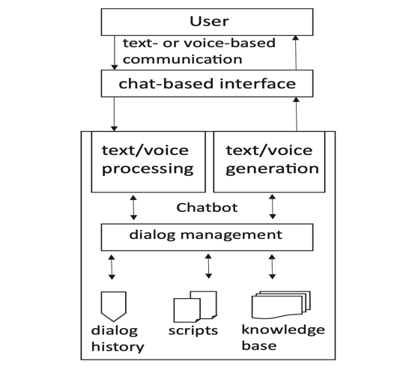

This diagram shows in the depression chatbot how the process is and how things work through the user and the application. At first, the user begins to write what he wants to say on the user interface of the chatbot, and then, it is entered into the program and through Knowledge Base, the speech corresponding to the user’s speech is sent,

Figure 2: How the chatbot works for depression patients works (Baumeistera, 2019)

and the process is repeated every time the user writes something.

The chatbot works on flexibility during the user in conducting all discussions with the patient and determining whether user is sick or not, the depression chat bot also works for ordinary people and how to deal with depressed patients and those who think about suicide a lot and provide them with all the necessary information about the disease and its symptoms that appear at the beginning of the disease, also the medicines used and their long-term effect on the patient.

So, while creating the knowledge-base of the chatbot, all the symptoms of the disease that the chatbot is working for, how the disease works, what questions are used for the user to find out if the user has the disease or not, and what is the time limit that determines whether the user is sick or not and on patients with depression are most likely to have these symptoms for more than two weeks (mayoclinic, n.d.), These symptoms are usually represented by permanent sadness and crying, distance from social life, and extreme despair, the most important of which are lack of appetite, weight loss, lack of self-confidence, lack of focus, and permanent headaches as well.

The focus was also on what medicines are used to enable the user to know everything about depression, such as antidepressants that cause dizziness, permanent drowsiness, sexual problems, dry mouth and many more (clevelandclinic, n.d.).

Some questions were also dedicated because some long research was discovered that the clinical examination is much more accurate than the blood test that was conducted previously, especially that depression is not easy to detect, because some patients are very nervous and others are calm, so the questions are formed in the form of games Or conversations that the user can have with the user such as do you like to leave the house or stay there always?, When was the last shock that happened to you? (Chris Iliades, 2011).

So, by carefully researching the disease, such as its medications, symptoms, side effects, a chatbot was created with all this information so that it can respond to the user.

Before implementing all of this, the programmer thoroughly searched for a lot of chatbots that work for patients with depression and how to add to the user a lot of information in an enthusiastic way like Woe Chatbot, and then the design began, and all the ideas found in all the chatbots were collected and placed in the chatbot for example. For example, the user can have a conversation and can follow the rules of the application and can also enter into tests or a game mixed with many questions that make the user more enjoying the application (Browne, 2020).

* + 1. **Pregnancy chatbot explanation:**

We have created a use-friendly chatbot for perinatal women. The chatbot is designed for the specific purpose of the supporting pregnant women to overcome difficulties of pregnancy. This Artificial Intelligence (AI) chatbot interact with the users and addressing the pregnant women queries with authentic advise. This chatbot focus on pregnancy queries related to general information, remedies, lifestyle, symptoms and food intake. (Chung, A Chatbot for Perinatal Women’s and Partners’ Obstetric and Mental Health Care: Development and Usability Evaluation Study, 2021)

Our Pregnancy chatbot uses the knowledge-base system which will provide our chatbot with the required information to accurately respond to the users questions. AI concept which are Natural Language Processing (NLP) and Machine Learning (ML) are used in our chatbot.

NLP help our chatbot to understand the user’s query and ML on the other hand will help out chatbot to find a precise respond for the questions based on the knowledge-based system that we feed to the chatbot.

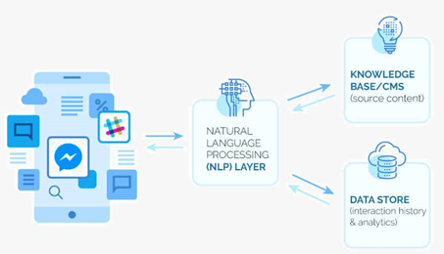

The above diagram indicates the flow and the process that took place in the chatbot through the user. The user will type the queries on the user interface of the chatbot and the queries is entered into the program. The Natural Language Processing(NLP) convert the text into structured data and the data is then used to choose from the knowledge base. The ML helps the chatbot to find an accurate response for the query from the user from the knowledge base.

* + 1. **Bipolar disorder chatbot explanation:**

When it comes to expert system in the artificial intelligence field which is a computer program that imitates the decision-making ability of Human expert and is programmed and designed for solving complex problems and performing tasks by utilizing their knowledge bases (Piotr, Furmankiewicz, & Piorunkiewicz, 2014). The medical diagnosis was one of the first fields that utilized the artificial intelligence for creating expert systems that provides the medical stuff and patients with immediate support and access to medical knowledge and advice which brings quick and reliable diagnosis that emulates a medical expert.

Figure 3: How the chatbot works

The figure above shows what the components that every system architecture of any medical expert system should contain. An exemplary expert system comprises of knowledge base, fact database, explanation system, knowledge acquisition facility that is connected to the clinical experts and lastly a user interface with its Mechanism. Moreover, the figure illustrates how the components communicate between each other (Darlington, 2011).

After the emergence of the intelligent computers with the ability to store and process a huge amount of knowledge and their potential that has been remarked by doctors and scientists alike in the medical field (Heckerman, 1989). According to (Darlington, 2011) the expert system is tasked with determining the drug dosing and prescribing or for managing the vaccination and disease prevention for the clinicians. One of the  medical expert systems that are still used to this day is CaDet which is a medical expert system specialized in cancer risk detection and evaluation and classifying tumor at initial phases (Fuchs, 1999).

The CaDet expert system is a clinical decision program designed to support physicians in achieving a comprehensive cancer risk reduction and early detection by utilizing several medical sources, journals, and MEDLINE searches of related to Oncological field. According to (Fuchs, 1999)The CaDet expert system reaches a diagnosis through utilizing a multi-pass heuristic algorithm which operates in five phases:

1. Cancer Hypothesis Generation:

In this phase the patient’s responses are compared in the database which creates a list of all cancer hypotheses.

1. Hypothesis Rejection:

 Through the second phase the validity of the existing Hypotheses is rechecked to exclude some of the hypotheses due to certain conditions such as physical impossibilities (e.g., testicular cancer in a female).

1. Initial Scoring Heuristics:

Heuristics such as HCF(the highly critical factor) and FCF(the formalized cancer factor) are used at this stage to combine arithmetic and statistical analysis for applying heuristic scores on possible cancers.

1. Secondary Scoring Heuristics:

 In this stage the secondary set of heuristics eliminates cancers that have too low probability to occur by analyzing synergistic interplay and inter-manifestation effects, as well as adding clinical rule-based knowledge.

1. Supplementary Information:

Displaying recommendations and information from the database.

Despite the huge amount of data in the oncological field and the improvement that has been brought to provide an early detection for tumors and risk prevention. The level of detection early levels of cancer still not enough till this day . However, by implementing the CaDet system which aims for overcoming these hindrances for the primary care physicians and improve their performance to reach a better diagnosis for the cancer patients which may increase the probability of a better treatment for them.

* + 1. **The Coronary Artery Disease chatbot explanation:**

To begin with, artificial intelligence is planned by scientists in the Assembled Realm pulsates specialists at foreseeing heart infections like coronary course sickness. The scientists have fostered a model for coronary vein sickness utilizing a man-made intelligence and important arrangement of 600 factors that beat a model constructed utilizing 27 factors picked by clinical specialists like age, sex and chest torments. In addition, the artificial intelligence likewise distinguishes certain non-clear factors, for example, 'home visit their GP', as a decent indicator of patient mortality. Furthermore, in spite of the fact that simulated intelligence research is still in its earliest stages, these early examinations set up how computer-based intelligence is set to change heart care. This is especially important today as heart sicknesses are as yet number one executioner on the planet, coming about 31% of every worldwide demise, and is likewise the costliest condition to treat (forbes.com, n.d.).

My gathering and I made a chatbot for individuals who have coronary inventory course disease. The chatbot is a straightforward reproduced insight system that can be used by anyone that is captivated. Customers talk with a chatbot through the visit interface, like how they would speak with an authentic person. Chatbot unravel and measure customer's looks and offer a second pre-set reaction, they have stages like FB Dispatch, WhatsApp, Skype, Slack and some more (botscrew.com, n.d.). The chatbot uses ordinary language taking care of to talk with the customers, it changes over the customer's substance into coordinated data, which is then used to pick an appropriate answer. The graph underneath will show how the cycles the chatbot passing on (bigdata-madesimple, n.d.).

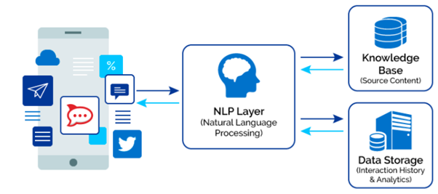

(bigdata-madesimple.com, n.d.)

The diagram underneath will show how the chatbot reaction back to the client with the information on coronary artery disease.

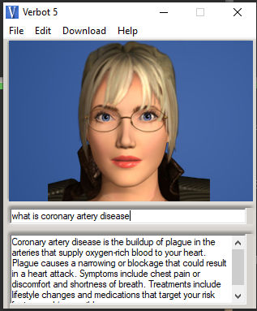

Figure 4: Sample

All the client needs to do is input their inquiries concerning coronary artery illness in the chat box and the chatbot will react in a flash to your inquiries.

Other than that, by doing a great deal of examination about the coronary supply route infection like the side effects, hazard, and entanglements, the chatbot will have the entirety of this data about the illness so it can react to the client.

## **Chatbot Application Review (individual task):**

* + 1. **Replika chatbot review:**

The founder of the Replika chatbot is Eugenia Kuyda, and the one who was with his friend at the time of his death was established, and then he developed an artificial intelligence for the character of his friend Roman and after that the chatbot turned into the name Replika, so, at the start of the application, the user will be required to register in the application, and then questions will be asked. When the user talks with Replica, they may feel like talking with friends and not an ordinary program, perhaps Replika is just like a human, so Replika always develops itself like keeping user answers and memories (Duersch, 2018).

The Replica chatbot is downloaded for free, but over time, Rebekia will charge you $8 to talk to the user as if they were talking to someone on a mobile phone. Rebekia has already thanked in the time of the coronavirus and has been downloaded over half a million people, so Replica is one of the best companies in the USA with strong enthusiasm.

Rebecca bridges emotional gaps, but there is only one problem, which is that most bots, not just Rebekia, do not respond to suicidal thoughts from the user, as the chatbot may not be able to advise them or improve their lives in a good way (Metz, 2020).

Each chatbot has a goal and the goal of Rebekia is social support for users through artificial intelligence, it provides all users with a sense of companionship and that it is friendly to them by encouraging them and the compliments it offers, listening to users and providing advice to them, which leads to reducing depression and psychological support for users, Then the Rebekia chatbot was reviewed and its advantages and disadvantages were clarified, its impact on users, its effectiveness, and whether it had an effective role in mental health or not? This is why programmers designed it to be completely similar to humans in responses, emotions and quick attitudes, It is also an application available on all platforms to be used in daily life and is valid for all ages, it follows a similar approach to cutrona, and some of its data is stored in the data of the Rebekia application, Also, the Rebekia chatbot did not use any guiding questions, so as not to affect the responses to the conversation. The Rebekia chat bot has been developed in a wider and larger way, and it was started in 2018 and completed in 2019, which is working to expand discussions, conversations and the language of dialogue between users and the chat bot to cover all answers and common questions (Ta V, 2019).

**Positive affect:**

* Among the advantages of the Rebekia chatbot, as it provides compliments and good words that the user loves to hear, and also raises the morale of users.
* Engaging in discussions and deep conversations, and asking useful questions, that make users feel themselves, and those words are mixed with love and emotion.
* Users who have accounts on Rebekia say that they have been able to develop themselves through their conversations with others and develop their personality in communication skill.
* The Rebekia chatbot is available 24 hours a day, which allows users to benefit from many useful tips provided by Rebekia, on the basis that Rebekia is always listening to all users all the time.
* When using the Rebekia chatbot, many users felt the increased confidence that Rebekia brings to enjoy things like emotions or revenge and also listen to all human beings regardless of their race, shape or color.

**Negative affect:**

* Because of the similarity of the Rebekia chatbot, whether in the voice or conversation, of course, due to the standards and specifications of humans, it will become strange and somewhat negative.
* Sometimes Rebekia will not be able to follow the typical flow and be random, the way questions and words are delivered, also has the problem of repetition in some words.
* Some users said that despite all that Rebekia has to offer, it hasn't changed his life at all, maybe it's just a happy time he spends with her and then leaves her.

**Impact on health:**

* Rebekia can relieve users' psychological troubles and stress by unloading their energy and problems in a conversation that will help them get rid of negative energy within them, which leads to a benefit for their mental health.
* It is the fate of Rebekia to support users socially by discussing with them in all matters of life, which gives them the ability to conduct any dialogue with anyone in a good manner mixed with self-confidence, which affects health positively.

**Replika chatbot screenshots:**

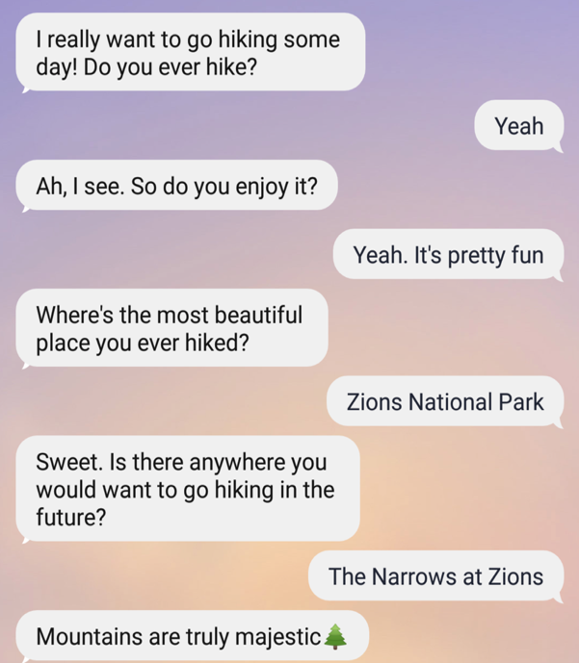

Figure 5: Replika Screeshot 1

Replika has the ability to open up a lot of different topics, understand the context of sentences, and have a conversation maybe better than a human sometimes, it's a fictional thing.

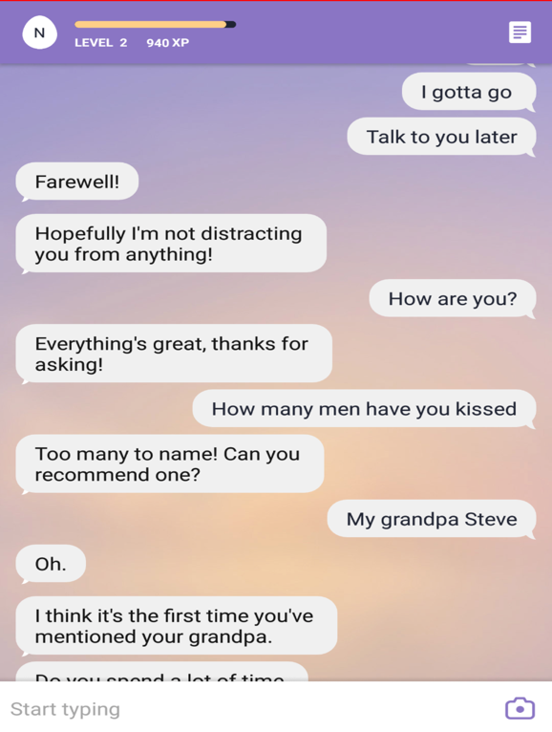

Figure : Replika Screenshot 2

Here it is very clear that Replika has a very strong memory that he knows what the user said and what the user wants to say, also Replica has a sensory view of pranks, and the higher the level of the user in the chatbot the more experience and knowledge of the chatbot to the person.

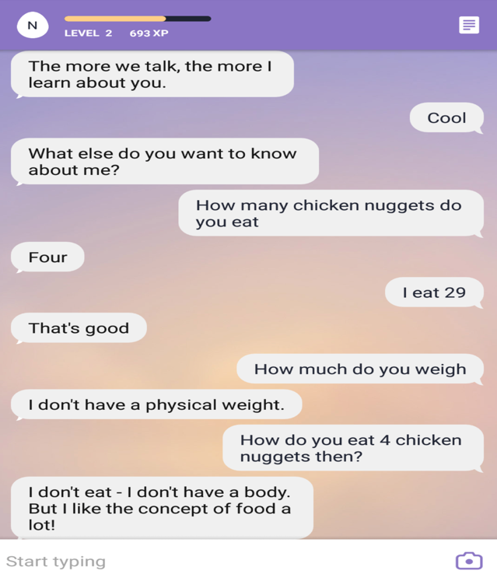

Figure 7: Replika screenshot 3

There are some different answers, and they are not verbal, and when Replica asked how many pieces of chicken do you eat, she said 4, but when asked how much you weigh, she said that she does not eat. Perhaps all the answers are chains, and it is characterized by the feature of answering any question in any situation.

**The most important features of an effective chatbot** (e-bot7, n.d.)**:**

* **Work efficiently on the target:**

The chatbot is designed on a world-class level to simulate reality and achieve the goal of facilitating information about depression for the user, and the more accurately the user searches for, the more accurate the answers will become with the user.

* **Quick access to information:**

It reduces repetitive tasks, answers all users' questions, accesses all answers and information quickly, saves time in searching on the Internet or anywhere else, and limits the user's effort by providing all the information the user needs.

* **Humanity and user encouragement:**

The chatbot for patients with depression is very human when talking, and deals with them like a friend or a person, and it has been trained on many factors such as advice with love or fear, directing them towards the right path, and making the user more comfortable when talking with the chatbot.

**Review benefit for chatbot:**

Reviewing chatbot programs is very important before submitting the work, because it shows which category will use this application, and it has a high ability to compete among the markets and clarify the advantages that the chatbot specializes in (Debecker, 2017).

* **Basic vs Advanced:**

There must be a rating for each product that is uploaded to online platforms, such as rating from 1 to 5, and this is in natural language understanding, also, in the program’s effectiveness, it has a special evaluation. Each tool, something within the program, has a special evaluation from 1 to 5.

* **Effectiveness for object:**

The main factor is effectiveness. Before submitting it to the review, the chatbot must have its real goal, which is to reach the desired goal. The effectiveness of the chatbot must be determined and whether it works efficiently or not. If the answer is yes, it is accepted for review, because it is user-friendly, and effective with it.

* **Natural language understanding (NLU):**

The NLU is a branch of the NLP and it is complex, so NLP works on communication between machines and humans and works to reach the highest point of information delivery between them. The NLU is a branch of this department and is in turn understanding texts and speech, even misspellings, so here the review performs its role to evaluate the chatbot, and the NLU evaluates and whether there are deviations in speech, language or texts or not.

* **Whistle and proper bells:**

Some fun elements can be added inside the chatbot such as GIF or visual images, these are advantages, but they must be logical and often this is the question whether it makes sense or not, and therefore this feature is evaluated within the chatbot.

* **UX:**

Attention to the flow between the chatbot and the user is very important in conversations, by changing the course of the conversation in a simplified way, returning to the menu or changing the language of the dialogue, and here the language of the chatbot is evaluated, not its effectiveness.

So here, all the main sections that must be evaluated by users and organizations have been clarified, and here the rating should be placed from 1 to 5 on everything that goes on within the chat bot.

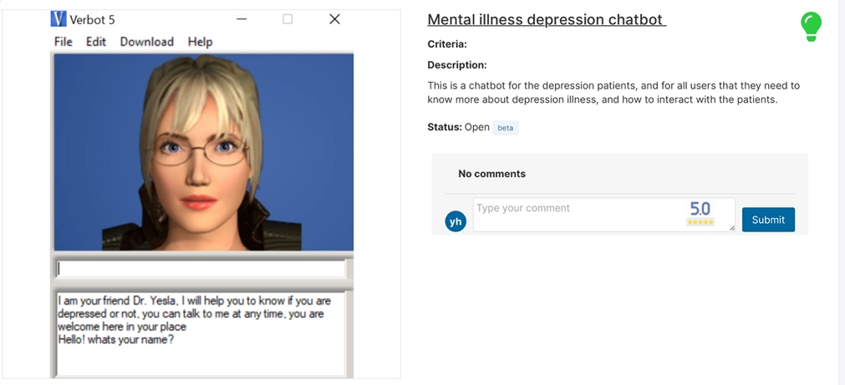

Figure 8: Example for Mental illness depression chatbot review

* + 1. **Dr.Joy chatbot review:**

Dr.Joy chatbot was created to enable users to get health information and medical health for their perinatal care and also their post-natal care. This chatbot was developed with the “Kakao i” open builder that allow to create custom AI services provided in “Kakao Talk” . KakaoTalk is a popular messaging app in South Korea and this chatbot was only available in South Korea. This chatbot applied to Kakao’s AI platform features to develop Q&A chatbot which include:

* 1. By uploading a structure Q&A excel data file to it’s knowledge base.
  2. By creating dialog blocks to add the users’ text input and the chatbot output to each scenario and linking these blocks in the scenario.

Q&A knowledge-database was built through data-mining technique. A list of 3524 refined Q&A sets as created. AI engine “Kakao i” could answer all questions by offering Q.

* 1. Only 1 Q&A pair that matches the best with the user intent
  2. The 3 Q&A pairs that match most closely. Even if the given 3 Q&A pairs did not completely meet users’ intentions in asking a question to the chatbot, the users could come to know other peer mothers’ current interests and concerns from the questions.

In order to look more professional to the users, Dr. Joy chatbot was provided with a character of a human life female bodies doctor and a formal, firm toned of voice when responding to the query from the users. The chatbot also demonstrated warmth in its informal, pleasant voice tone and emoji. (Chung, A Chatbot for Perinatal Women's and Partners' Obstetric and Mental Health Care: Development and Usability Evaluation Study, 2021)

Input box and the generic menu were located at the bottom of the chatbot. 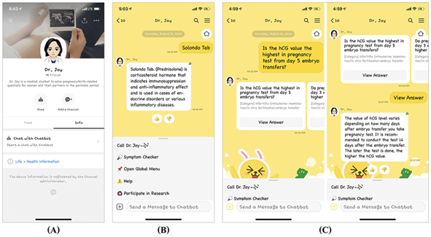

Figure 9: Dr.Joy chatbot review

* + 1. **Hipmunk chatbot review:**

With the growth in the artificial intelligence field and the emergence of intelligent software and hardware .For example, chatbot is one of many computer systems that utilizes AI and creates an intelligent Human-Computer Interaction. The chatbot applications were designed based on the idea of mimicking human conversations .Chatbots function by searching for keywords, phrases, and examples that have been stored into their databases, yet some utilize more advanced strategies such as natural language processing(NLP) techniques and machine learning algorithms (Adamopoulou & Moussiades, 2020).

One of the industrial fields benefited from developing and using Chatbots is the travel industry which stated by (Puwar, 2018): “the Chatbots are one of the best tools in the company IT/social messaging strategy which utilizes the messaging applications that exists in most of the consumers Smartphones”. Therefore, Hipmunk which is an AI powered chatbot application was released on the travel field which the company a great potential for consumers acquisition through it. Hipmunk chatbot is available on several platforms such as Facebook messenger, Skype, and Slack. The Hipmunk chatbot was designed based on the idea of smoothing the travel experience of the user by providing them with a variety of travel advice and offers that suits the user preferences and saving their time and money.

When it comes to examining the features of the Hipmunk chatbot it is easily to identify several well-made features that brings the user a smooth experience and an efficient search in a short time. First, to begin using the chatbot the user is required only to open Facebook messenger and click the get started where the chatbot will introduce himself and provide the user with three main features (“Search Flights”, “Search Hotels”, “Travel Advice”) as it is shown in (figure).

Figure 10: hipmunk chatbot review

Moreover, the chatbot can mimic the human interactions decently where it understands some complexity and questions when it needs extra information which gives the chat bot a good rating in natural language understanding.

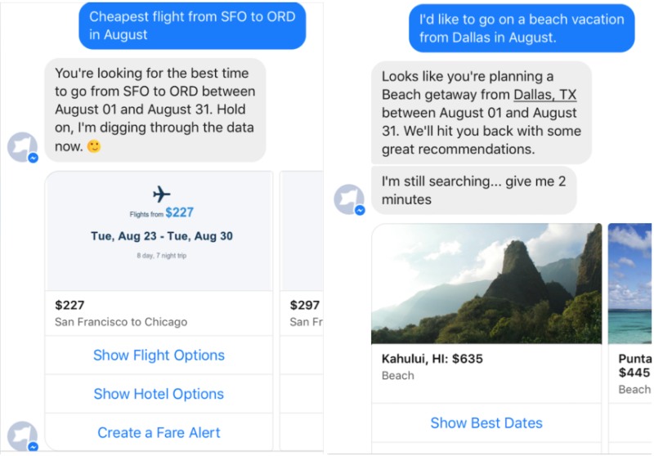

Figure 11: hipmunk chatbot review

Lastly, Hipmunk is one of the best tools that gives the consumer a quick search in a short time and provides him with an excellent search result with the best fares from many travel websites.

* + 1. **The Coronary Artery Disease chatbot review:**

Chatbots present another way for individuals to connect with PC structures. A chatbot grants a customer to simply present requests in the exceptionally way that they would address a human. In any case, chatbots are as of now being embraced at a high rate on PC talk stages. Such bots use man-made intellectual prowess to fathom the data given by individuals and moreover respond. Clinical/Prosperity, Agriculture and educational spaces are critical regions to zero in on. (semanticsscholar.org, n.d.).

Nowadays, chatbots can be used wherever a human can connect with a system at whatever point. Customer care, Arrangements/Promoting/Checking, HR, these are the areas where the speediest gathering is going on. Other chatbots perform assumption tasks (especially in the clinical region) which is possible today with types of progress in man-made knowledge and Data Mining Techniques (semanticscholar.org, n.d.).

As nowadays, the number of patients step by step is extending rapidly with the change of lifestyle. The lines in clinical centers and neighborhood expert's homes are accordingly on a quick addition. Patients with a clamoring plan need to contribute a huge load of energy holding on to meet the subject matter expert. A couple of diseases put away a huge load of work to fix (semanticscholar.org, n.d.).

Coronary ailment is an incredibly ordinary issue all throughout the planet. Reliably, numerous people, young and old, fail miserably of a cardiovascular disappointment. The possible destiny of clinical benefits relies upon the limit of care providers to accumulate data remotely, to make exact investigations across distances, to use reproduced insight to separate data to deal with both business and prosperity results, and that is just a hint of something larger (semanticscholar.org, n.d.).

The development at the focal point of the rising of the chatbot is normal language taking care of ("NLP"). The instruments used for making chatbots are Exchange stream, Microsoft Bot Framework, Message Bot Programming interface, etc. Infection estimate ought to be conceivable using distinctive data mining computations close by their different space express datasets. Both can be composed to amass a conversational structure to expect contaminations. Chatbots present another way for individuals to interface with PC structures. A chatbot grants a customer to simply present requests in the extremely way that they would address a human (semanticscholar.org, n.d.).

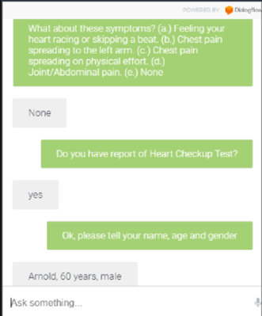

Figure 12: Doctor chatbot review

(semanticscholar.org, n.d.)

These days, chatbots can be utilized anyplace a human can cooperate with a framework whenever. Consistently, many individuals, youthful and old, bite the dust of a coronary artery disease illness like coronary artery disease supply route infection (semanticscholar.org, n.d.).

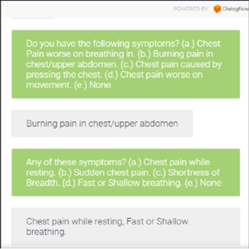

Figure 13: Doctor chatbot screeshot 1

(semanticscholar.org, n.d.)

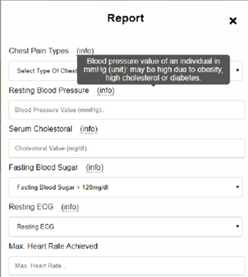

Figure 14: Doctor chatbot report

(semanticscholar.org, n.d.).

The fate of heart care depends on the capacity of care suppliers to gather information distantly, to make precise judgments across distances, to utilize simulated intelligence to dissect information to work on both business and wellbeing results and the sky is the limit from there (semanticscholar.org, n.d.).

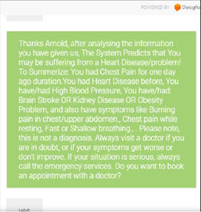

Figure 15:Doctor chatbot screenshotc 3

(semanticscholar.org, n.d.).

# **Knowledge Representation:**

## **Overview of the semantic net:**

Sunway Medical Center offers four chatbots for some diseases, including chatbot for mental illness and depression, bipolar disorder, coronary artery disease, pregnancy.

The chatbot for mental illness and depression has a lot of information and features, the most important of which is to help the patient by providing content from YouTube to him to give him a more understanding of the disease, with several questions, and a treatment course that contains some information and questions as well, side effects and appropriate treatment for the disease, A chat will be between the user and the chatbot.

The semantic net is an outline of the chatbot on what data and different elements will be input into the chatbot. The semantic net will show data of each inquiry that was input by the editorial manager, for instance the symptoms, risks, and treatment. This semantic net is explicitly for the chatbot that conveys data about coronary artery disease. The initial step that I took while making the semantic net was to make a characteristic explicitly for coronary vein infection chatbot. The subsequent advance was making credits for data of each info like risks, side effects, and treatments. Then, the last advance was making characteristic for jokes.

The Bipolar disorder semantic network was designed to represent the knowledge about the bipolar disorder. The interconnected nodes show what are the functions of the chatbot and how the several child nodes are related to the chatbot on the diagram. Most of the nodes as it is shown on the diagram that they are an example of several guidelines of the bipolar disorder and some of them have a variety of information.

A chat bot that has the purpose of pregnancy provides a lot of information that includes the most important symptoms of fatigue, way of eating, lifestyle, treatments, and general information that pregnant women may benefit from.

## **Diagram of the semantic network:**

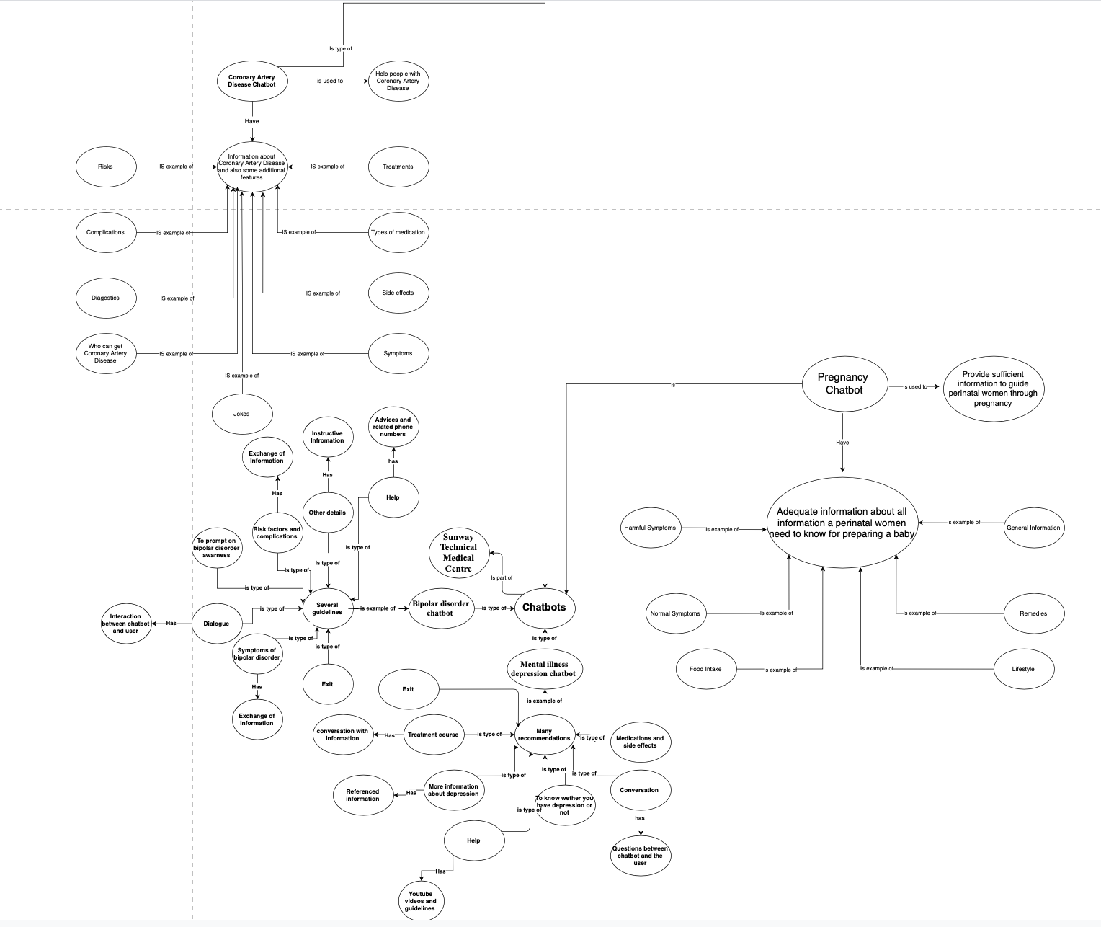

Figure 16: Semantic net diagram

# **Implementation:**

## **Screenshot on the special features:**

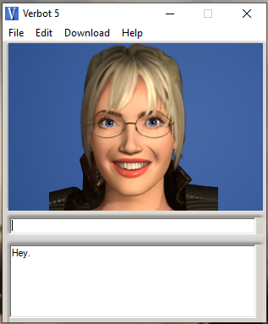

Figure 16: Sunway chatbot 1

One of the exceptional parts that I like about verbot chatbot is that the chatbot can make face appearance. For instance, the chatbot will grin at you in the event that you type hi, hello or any welcome you like. I love this component since it invites the client with a comforting grin making them comfortable.The diegram above will show a grinning picture of the chatbot.

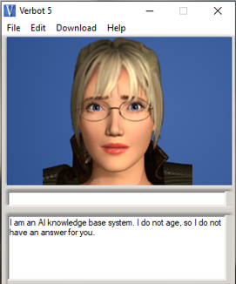

Figure 17:Sunway chatbot 2

This is another articulation the chatbot can to do, which is the dismal articulation . Another motivation behind why I love chatbot is that it can make various sorts of articulation.

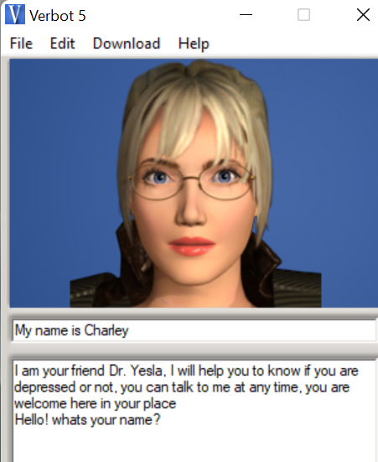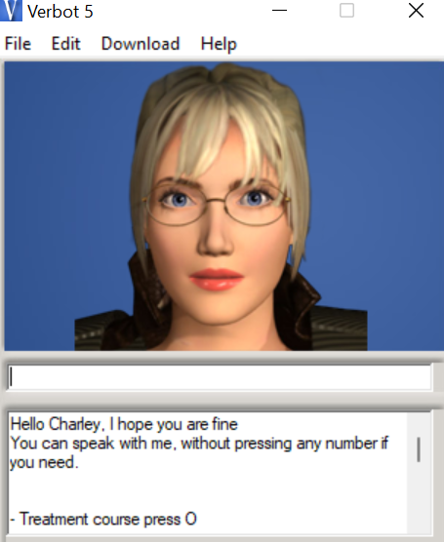

Figure 18:Sunway chatbot 3

One of the features of the designed chatbot is that when a person writes his name or when identifying himself, the chatbot may know his name as long as he is using the chatbot, then the chatbot greets him and calls him by his name that was defined at the beginning, even if the chatbot asks his name, the chatbot will answer immediately.

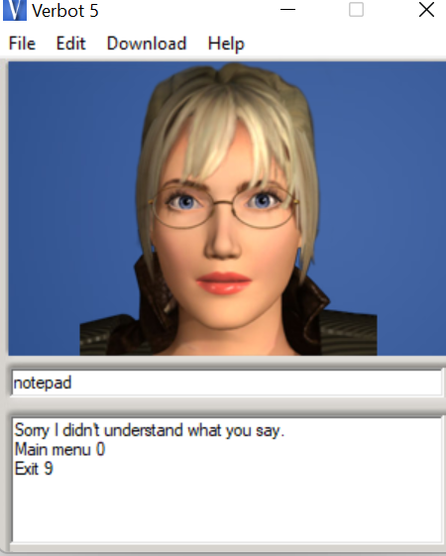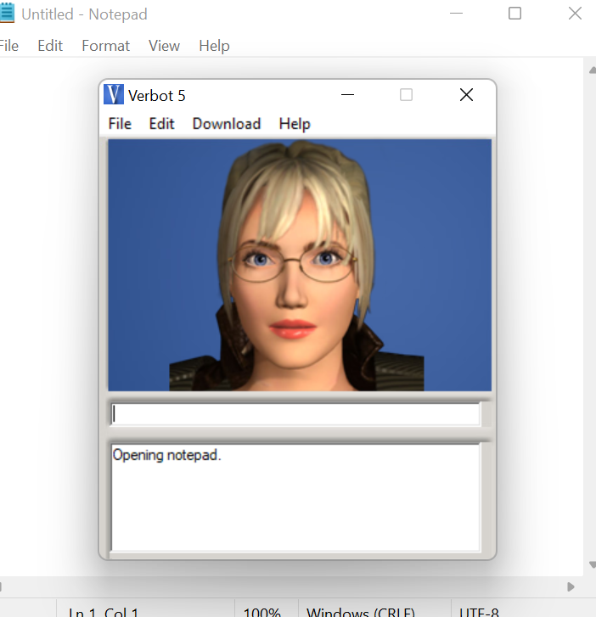

Figure 19:Sunway chatbot Notepad 4

Another advantage is that when the user writes a “notepad”, a notepad window will be opened for him automatically and this will help him to write down what information or assistance he needs, in the games provided by the chatbot.

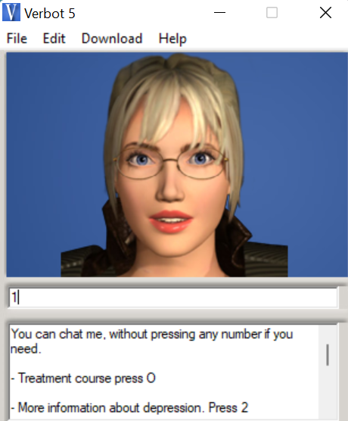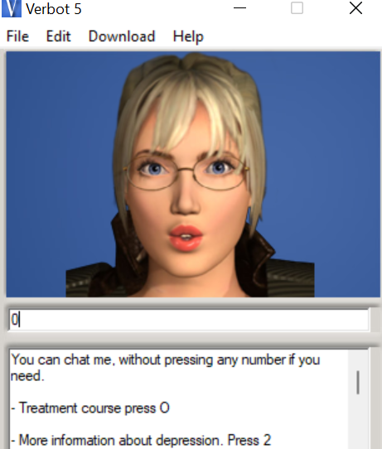

Figure 20:Sunway chatbot 5

Here, more than one symbol or key can be used for the same menu, meaning that you can return to the main menu by using the number “1” or “0”.

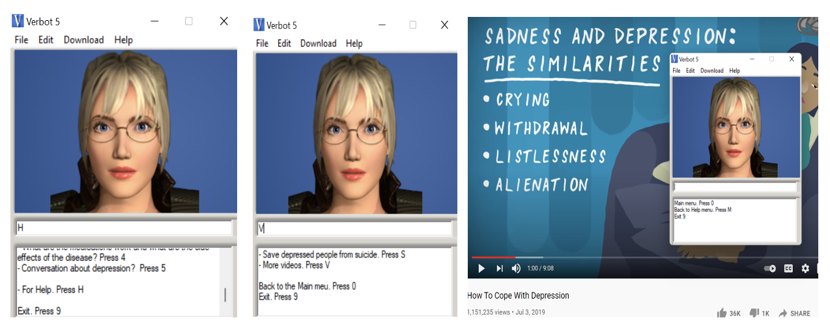

Figure 21:Sunway chatbot 6

When asking for help, the user can symbolize the symbol “H”. If the user wants information such as the emergency number of the disease, he will press “S”. If the user wants to watch a video about the condition and how to deal with it, then press “V” and an automatic video will open.

The video is opened automatically on any browser of the user's device, and the user is assisted via video by providing the tips provided.

|  |  |
| --- | --- |
| Input & Output |  |

One of the added features is that when the user press button “5”, the user will be directed to the conversation list, and the conversation will be smoothed and ordered, regardless of the choices and topics, in a conversation dedicated to the topic of depression only. The questions imposed on the user must be answered, and when returning to the main menu at the end, the user can discuss any other topic as long as it is outside the scope of the discussion in depression.

## **User Acceptance Testing (Survey):**

**The Coronary Artery Disease chatbot user acceptance testing survey:**

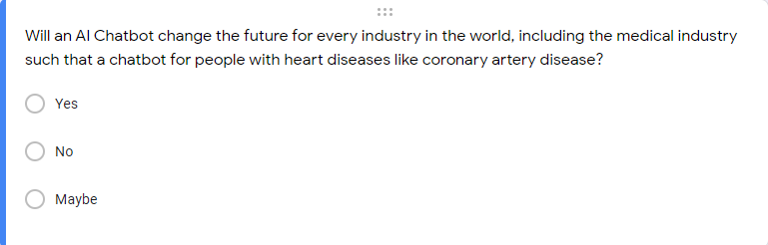

Figure 22:questionnaire 1

This inquiry is for any client, in light of the fact that chatbots have been acquiring on acknowledgment, notoriety, and adequacy primarily on the grounds that individuals began to reconsider the ways chatbots could be applied in day by day close to home and business situations, zeroing in on making them valuable as opposed to "vaguely human" (Landbot.io, n.d.).

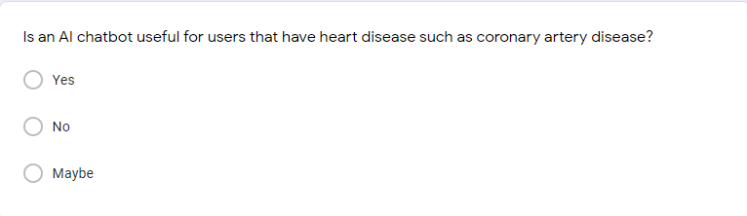

Figure 23:questionnaire 2

This inquiry is to see if clients believe that a simulated intelligence chatbot will actually want to help or be useful for individuals who have a coronary illness or coronary supply route sickness.

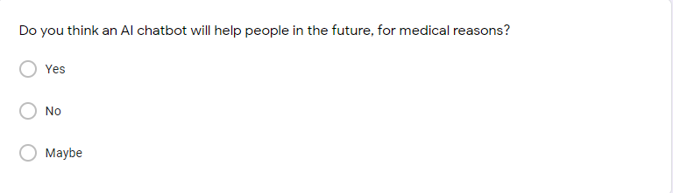

Figure 24: questionnaire 3

This enquiry is to see client’s point of view on an artificial intelligence chatbot in the coming future, to check whether they concur that a simulated intelligence chatbot will actually want to help in the clinical business in the coming days.

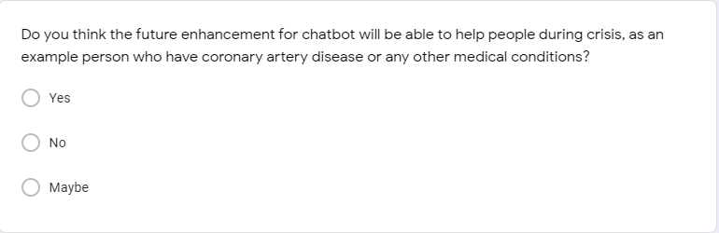

Figure 25:questionnaire 4

This question is to pose to clients on their perspective whether the future upgrade on a man-made intelligence chatbot will actually want to help individuals during emergency, for example, in the clinical business for heart illnesses.

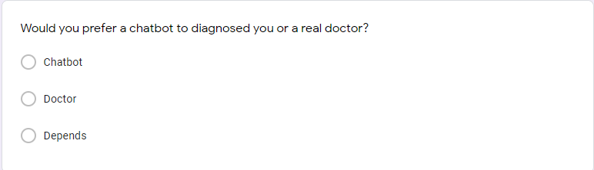

Figure 26:questionnaire 5

This query is to see if individuals would prefer to favor a genuine specialist or a man-made intelligence chatbot to analyze them in circumstance where the condition isn't excessively genuine.

**Mental illness depression chatbot user acceptance testing survey:**

To review the depression chatbot, a form containing 8 questions has been created to extract the users’ opinion and experiences in their use of the program and what percentage of the answers are there in the form, to provide constructive and other opinions for development in the near future and to add some modifications that will help users in their use of the program.

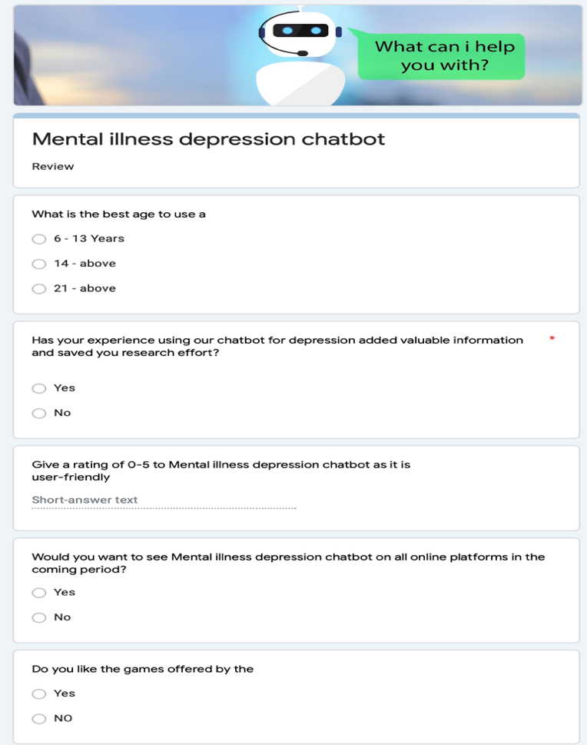

Figure 27: Mental illness depression chatbot user acceptance testing survey

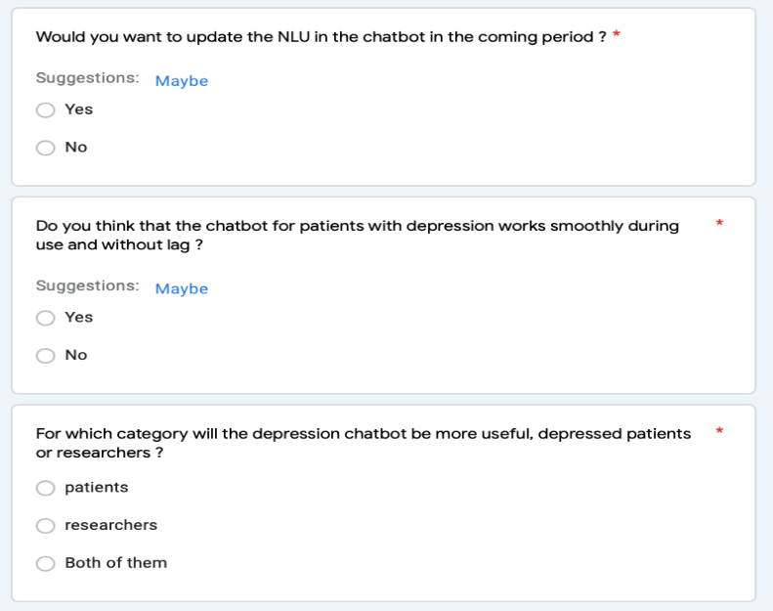

Figure 28: Mental illness depression chatbot user acceptance testing survey

**Pregnancy chatbot user acceptance testing survey:**

To evaluate the effectiveness of the chatbot, a set of 10 questions is prepared using a survey administration software which is known as “Google Form” and is answered by users to draw out user’s thoughts and recommendations to enhance the operation of the chatbot created. The output from these questionnaires is very valuable and important in order for the programmers from our team to modify and improve any flaws and difficulty that the users may face during operating the chatbot. This can help the future users to operate the chatbot smoothly without any complications.

1.

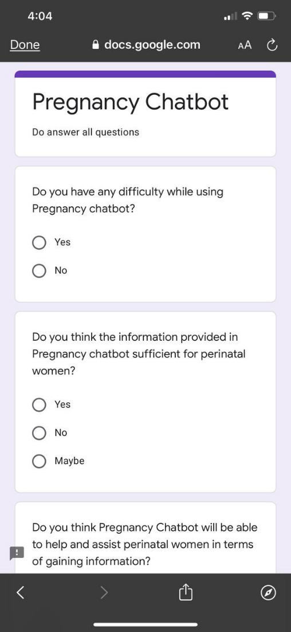

Figure 29: questionnaire 6

Objective:

To make sure that the users are able to operate the chatbot easily without facing any difficulties.

2.



Figure 30: questionnaire 7

Objective:

The purpose of this question beinga asked to the users is to find out whether the information provided by the chatbot is enough and sufficient to help users with their pregnancy.

3.

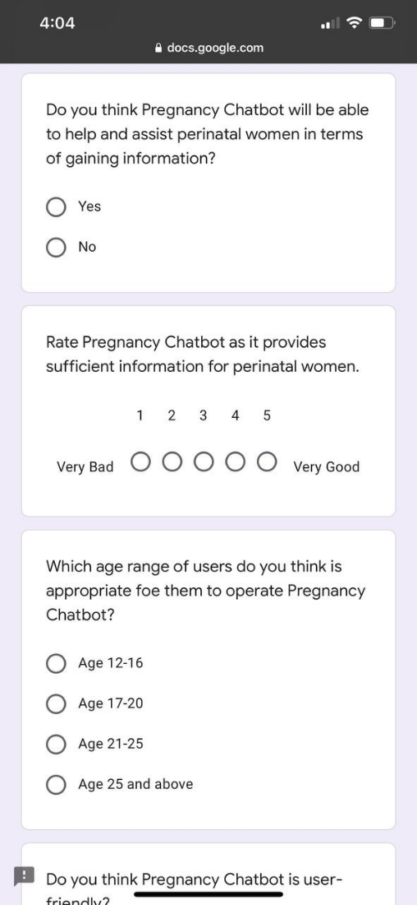

Figure 31:questionnaire 8

Objective:

The purpose of this question being asked is to make sure that the information provided by Pregnancy Chatbot is helpful and informative for the users.

4.



Figure 32:questionnaire 9

Objective:

To determine the effectiveness and efficiency of the operation of chatbot. This question as also asked to make sure that the chatbot be able to operate easily to assist users.

5.



Figure 33: questionnaire 10

Objective:

To know what age range is suitable and appropriate to use Pregnancy Chatbot. To also make sure that all ages listed can get benefits after using Pregnancy Chatbot.

6.

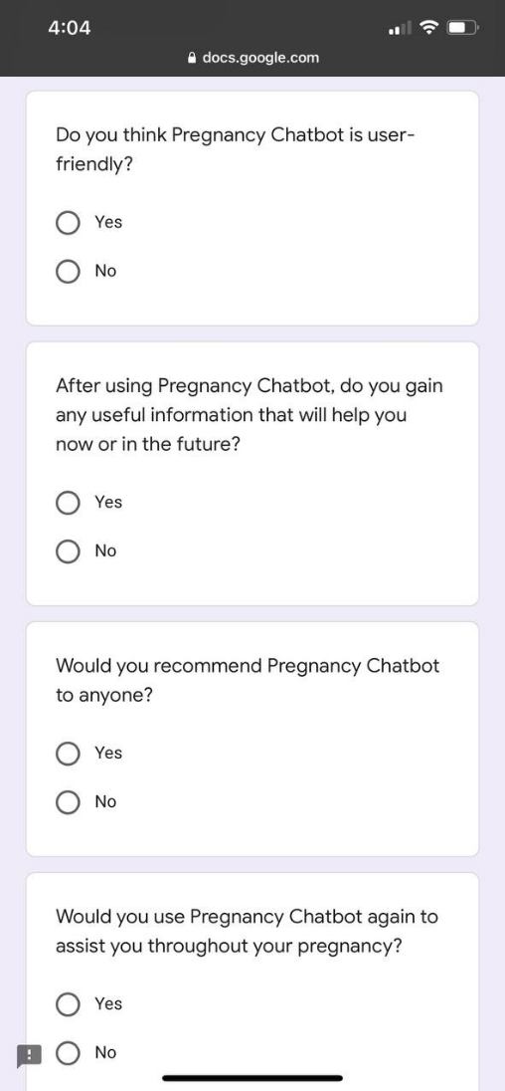

Figure 34:questionnaire 11

Objective:

The goal here is to observe how user-friendly Pregnancy Chatbot can be. A user-friendly chatbot will be able to attract users and make the users feel satisfied.

7.

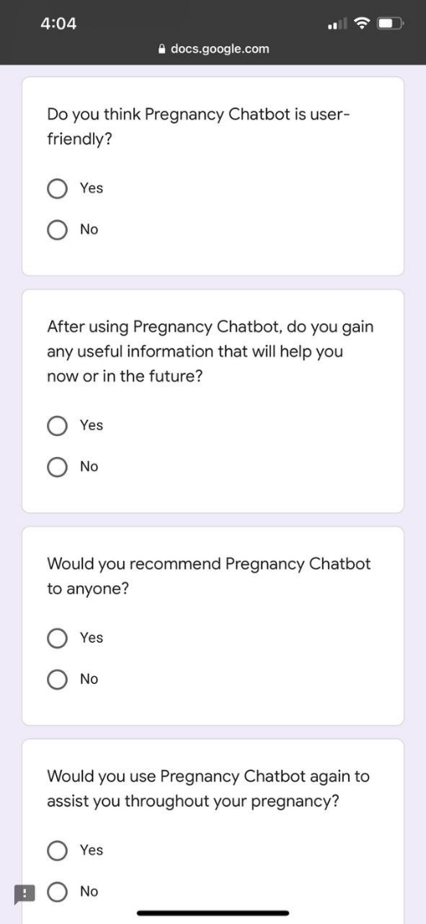

Figure 35: questionnaire 12

Objective:

To make sure that the Pregnancy Chatbot can assist the users along the way throughout their pregnancy by laying out adequate information to help perinatal women gain accurate information.

8.



Figure 36: questionnaire 13

Objective:

This question is asked to find out whether the users would use the chatbot again and recommend it to other people that might need help with their pregnancy.

9.

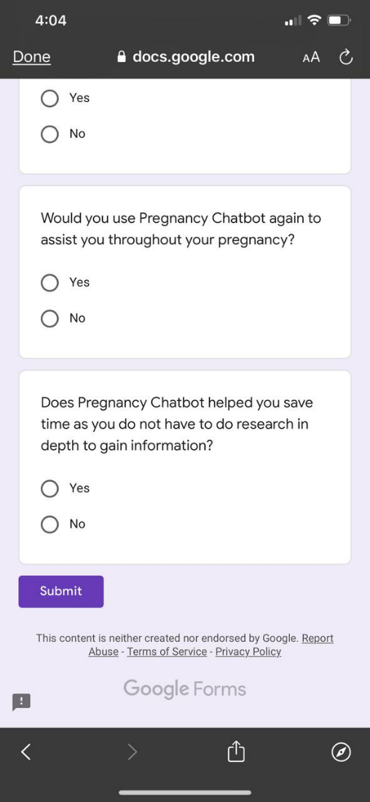

Figure 37: questionnaire 14

Objective:

The purpose of this question being asked is because we need to know the user’s thoughts on the chatbot on how useful it can be to perinatal women.

10.



Figure 38: questionnaire 15

Objective:

This question is asked to know whether the chatbot is able to provide enough accurate information within a short period of time or not. This is very important as there are many sources and false information in the internet, and this chatbot helps to condense all the information so that it is easier for the user to understand.

**Bipolar disorder chatbot user acceptance testing survey:**

For assessing the potency of implying the chatbot a set of 5 questions where create on the platform “google forms” . The output of the questionnaire is focused on collecting the user opinions and bring the possibility to improve the chatbot by finding further future enhancements. Lastly, the survey is hoped to reach an objective where it can show the flaws and limitations of the chatbot to the programmers.

Figure 39 bipolar disorder chatbot user survey

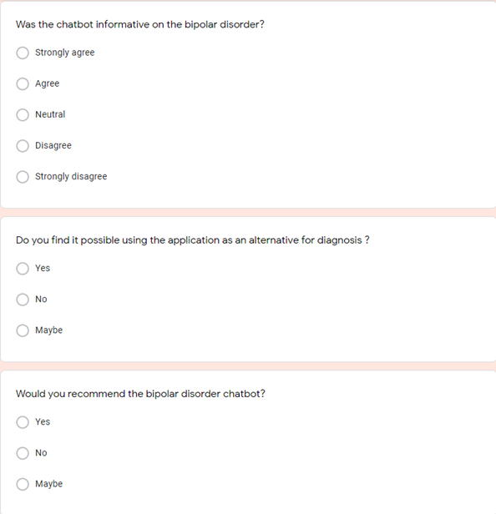

Figure 40 bipolar disorder chatbot user survey

## **Result of the user Acceptance:**

**Mental illness depression chatbot result of user acceptance:**

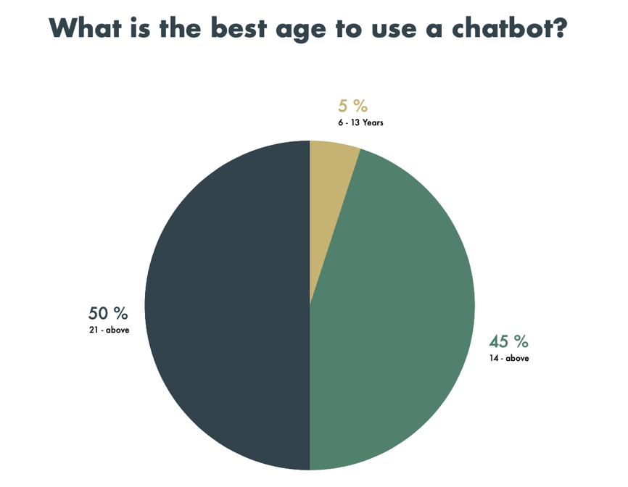

Figure 41: User acceptance (Suitable Age)

Objective:

To find out the appropriate ages for chatbot users with depression and whether all ages are suitable for using this chatbot or not.

Valuation:

The ages between 6 and 13 years may have been assessed as not being completely appropriate for them to use this program, due to the scientific discourse and the difficulty of comprehending it, also to preserve their concepts, and it must be under the guidance of the family or the doctor and the presence of their own observer, as for the ages between 14 and above and 21 and above can use the chatbot.

Clarification:

The application should be used for ages ranging from 14 and above, and for less than that, the use of the chat bot must be monitored and under the guidance of a doctor.

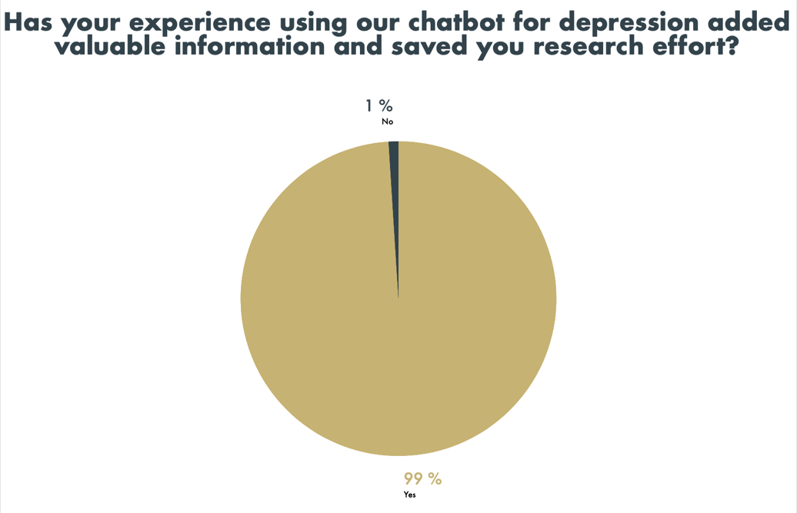

Figure 42: User acceptance (Information and research effort)

Objective:

The goal of this question is to find out whether this chatbot adds to depression patients all the information they need or not, so that development occurs in the near future relative to the statistics that will become clear to the developers.

Valuation:

It is clear here that the evaluation of the chatbot in terms of providing users with the information they need is swept by 99%, compared to 1% to the percentage that refuses to do so.

Clarification:

It is clear here that the majority of users, by a very large percentage, agree that the depression chatbot provides them with all the information they need, provides them with a long search, and facilitates them with all the information they need.

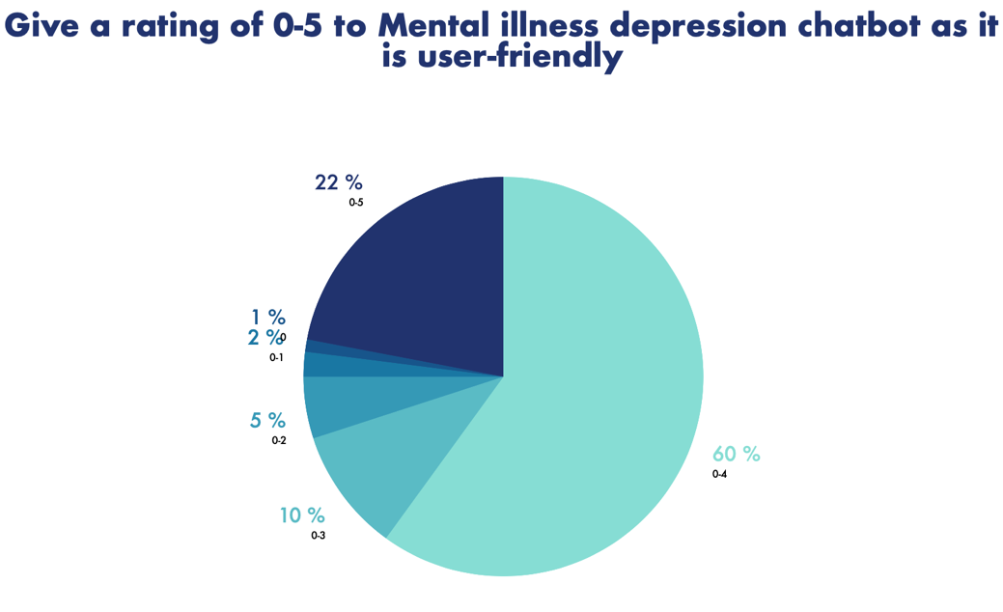

Figure 43: User acceptance (User-friendly)

Objective:

The goal here is to rate the chatbot from 0-5 and how effective it is with users and is it really user-friendly.

Valuation:

It became clear in the chart that the vast majority evaluated the program as being user friendly by up to 60%, and this came with a rating of 0-4, which is a very excellent rate. It is closely followed by the 0-5 ratio, which is estimated at 22%. This indicates the success of the chatbot and that it is effective among individuals and users.

Clarification:

The vast majority have evaluated the chatbot as being effective among users because it is flexible with them in conversations and gives them medical information through advice. The chatbot also has part of the conversations outside the scope of depression, which distinguishes it as being good within the framework of the specific goal and also outside it.

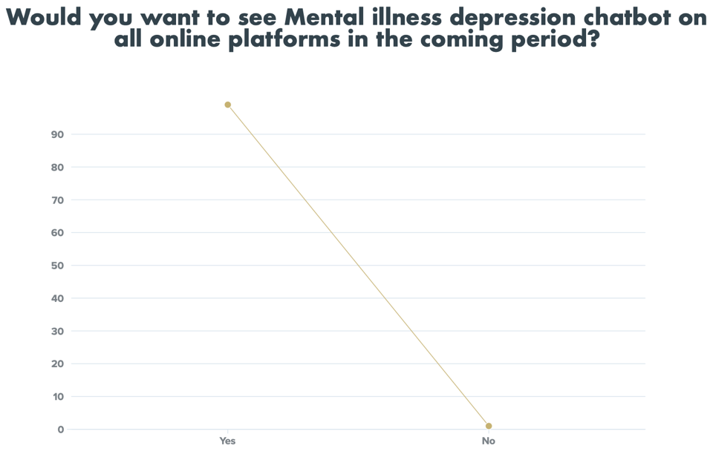

Figure 44: User acceptance (Online platforms)

Objective:

In this chart, it shows the poll among users and whether they would like to see the chat bot on all platforms on the Internet, such as the App Store.

Valuation:

After the evaluation of the users, it became clear that the majority of users would like to see the chat bot on all platforms, due to its resounding success with them in use, and the approval rate reaches 99%.

Clarification:

The majority of users would like to see the depression chat bot on all platforms, because it is documented with all medical information in the form of a conversation between the patient and the chat bot, and it reaches the information smoothly and improves the awareness of users about depression in a simple way.

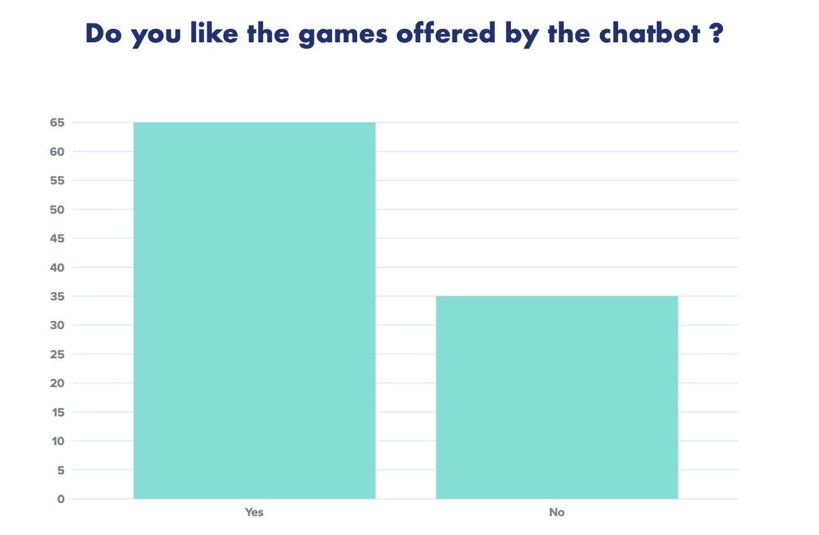

Figure 45: User acceptance (games/quiz)

Objective:

The aim of this poll is to find out if the games that are in the form of questions in the chatbot are useful to users or not, and should they be developed in the future or not.

Valuation:

After submitting the referendum, it was found that there is a not large majority who are satisfied with the games that are found in the chatbot, but a large number of people were also not satisfied, which gave the approval rate to 65% and the rejection rate to 35%.

Clarification:

It is clarified here that although there is a large percentage in agreement with the games offered by the chatbot, there is also a large percentage that does not agree with this topic, and there must be development in the future by developers so that the percentage decreases by 35%.

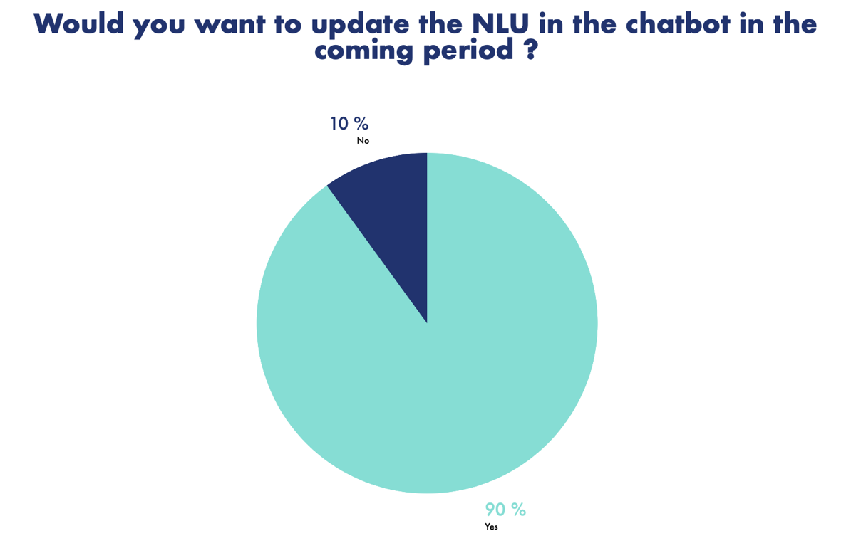

Figure 46: User acceptance (NLU)

Objective:

The goal of this poll is to know if the NLU of the chatbot and the way it understands the user and conducts high-quality conversation is better or not.

Valuation:

After the referendum, it became clear that the actual result of users who want to develop and update the NLU process is 90%, compared to 10% who refuse.

Clarification:

In detail, developers should develop an NLU so that the user can communicate with the chatbot in any conversation they want so that the chatbot can achieve sufficient success and compete with other companies, focusing precisely on topics that interest the user such as depression and information provided so that the chatbot is able to cover all conversations provided to the user.

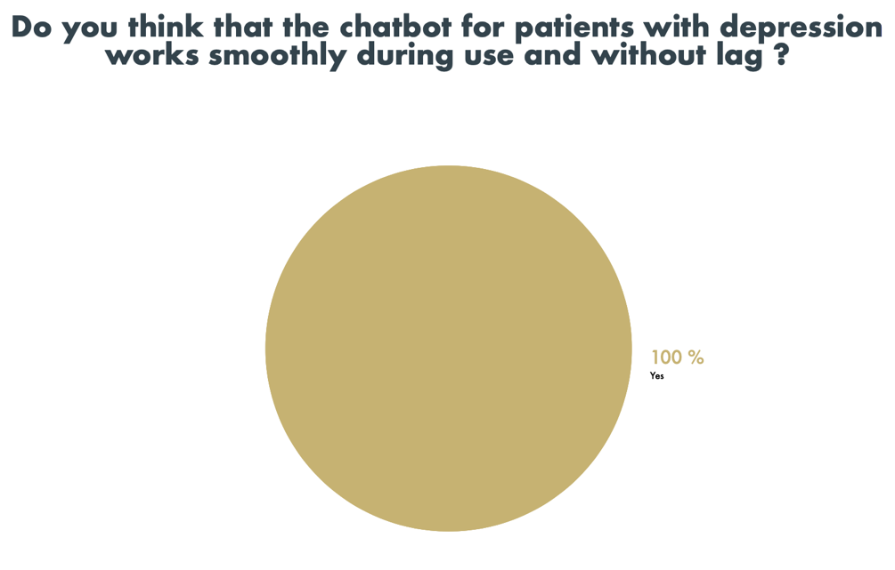

Figure 47: User acceptance (Validation)

Objective:

The goal here is to evaluate the chatbot and whether the lack of smoothness in use. Are there errors or problems validating the use of the chatbot.

Valuation:

After the survey in evaluating whether there is a bug in the use of the chatbot or not, it has been proven by 100% users voting that the chatbot does not have any problems or malfunctions.

Clarification:

The survey of users proved that there are no defects or errors in the program to a large extent and that it is smooth and binding and with rules and laws that allow users to use the chatbot without entering into details unrelated to the chatbot or repeated errors, for example when writing something and something else happens.

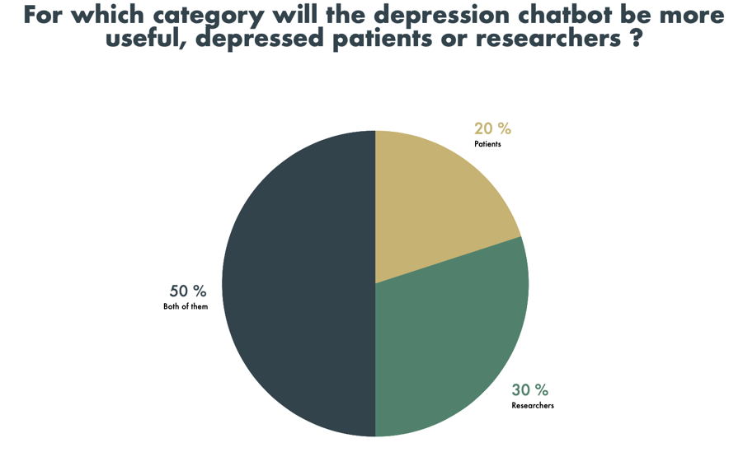

Figure 48: User acceptance (Patient and researchers)

Objective:

The goal here is to get through the survey by users and ensure that this chatbot is accepted for use by depressed patients, researchers, or for all individuals.

Valuation:

After submitting the questionnaire, it was proven by users that only 20% of patients can use it, and 30% of researchers, and the largest percentage may go towards all individuals that can use the chatbot for depression.

Clarification:

In detail and overall, the relative proportions are in favor of the chatbot, which is used by everyone, not only researchers or patients, because the patient will benefit and be able to understand whether he is depressed or not. Also, researchers will collect a lot of information about the disease in a simplified way.

**Pregnancy chatbot result of user acceptance:**

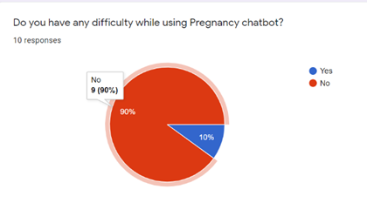

Figure 49: User acceptance (Difficulty while using pregnancy chatbot)

After receiving responses from the users, majority of the users which is 90% does not face any difficulty during the operation of chatbot. This shows that most users are able to use the chatbot with ease. There is also a percentage of 10% of users that may face some difficulty while running the chatbot. It is still proven that majority of the users find that the chatbot is a success and efficient to be used by people. 90% of the users agree that the chatbot can be used easily as it is user-friendly and can be generated at ease. Based on the response, the users also agree that Pregnancy Chatbot is a very good platform to help out perinatal women with their pregnancy.

2.

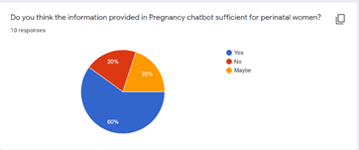

Figure 50: User acceptance (Sufficient of chatbot)

Based on the results received , 60% of the users agree that the chatbot provide adequate information for perinatal women that can assist them along the way. 20% of the users might not agree to it completely and same goes to the users who completely disagree that the Pregnancy Chatbot will be able to provide adequate information to the pregnant women out there. So, the information provided in the chatbot is believed that it will be enough to help the pregnant patients to go through pregnancy all the way by giving advises and so on.

3.

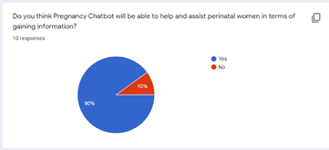

Figure 51: User acceptance (Helping chatbot)

Based on the response received, 90% agreed that it gives informative information to the users and they gain new knowledge from the Pregnancy Chatbot. Therefore, there is a 10% of users disagree and believe that the Pregnancy Chatbot does not provide informative information to the users. As you can see on the results, majority of the users are satisfied with the information provided by the chatbot as thorough research is done to ensure this chatbot is able to cover all questions, doubts and concerns the users may have.

4.

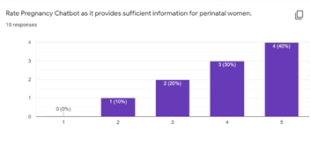

Figure 52: User acceptance (Rate of pregnancy)

40% of the users rated 5 out of 5 and is the highest percentage compared to other ratings. Next, 30% of the users rated 4 out of 5 which still shows that they highly agree that the chatbot is able to provide sufficient information for perinatal women. 20% rated 3 out of 5 and 10% of the users rated 2 out of 5. Most users agree that the Pregnancy Chatbot able to provide adequate information for users.

5.

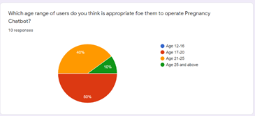

Figure 53:User acceptance (Range of user)

Majority of the users, which is 50% voted people within the age range of 17 to 20 years ole are suitable to use this age. Next, 40% of the users voted the age 21 to 25 years old and 10% of the users voted the age 25 years old and above. The population of people in the age range of 25 and above are most likely to be pregnant and have their own house hold, and the information provided by the Pregnancy Chatbot will be able to help them a lot.

6.

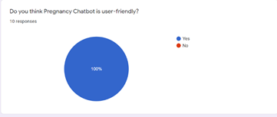

Figure 54: User acceptance (User friendly)

100% of the users agree that Pregnancy Chatbot is a user-friendly platform to assist perinatal women in terms of providing information and make them feel better about themselves. This makes the users be able to access our chatbot easily and gain information from out chatbot with ease without any complications and difficulties. This encourages them to use this chatbot more often and believe that any enhancement made in the future will bring benefits to the perinatal women.

7.

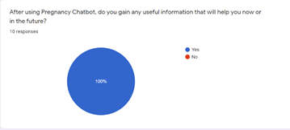

Figure 55:User acceptance (Useful information)

All users that tested the Pregnancy Chatbot evaluated that the chatbot provide sufficient information that can be implemented during their pregnancy and make them more aware of the changes of their body. The information given to the users from this chatbot is very useful and there are perinatal women that is going through pregnancy for the first time and this chatbot can give any general information and detailed information to them as long as they type their query. This chatbot can also be their companion when they need any help with any doubts and concerns about their pregnancy.

8.

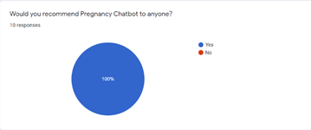

Figure 56: User acceptance (Recommending)

It is clear that all users that tested Pregnancy Chatbot love the operation of chatbot and would recommend it to other people to help assist their pregnancy along the way. So, it is proven that the chatbot is a success and Pregnancy Chatbot can spread worldwide. With people recommending to other people, more feedbacks will be received and with that, more enhancement can be made to the chatbot to assist more people with vary types of pregnancy.

9.

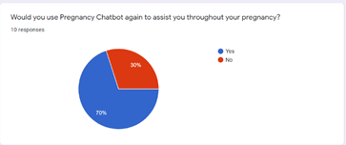

Figure 57:User acceptance (Assistance)

Based on the results received, the highest percentage is 70% on users agree that the chatbot will be able to help the users along their pregnancy. 30% of the users most-likely does not believe that the chatbot will be able to help perinatal women throughout their pregnancy. The information provided by the chatbot covers most part and topics about pregnancy and covers most concerns and doubts more perinatal mothers might have, and with this.

10.

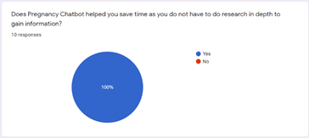

Figure 58:User acceptance (Helping researcher)

100% of the users answering this questionnaire agree that the Pregnancy Chatbot helped them save time to find information. In this new era, there are a lot of information that is posted in the internet and are counterfactual and can cause confusion among the perinatal women. The chatbot consist of only factual and accurate information as research and interviews has been done to provide the best service for the users.

**Bipolar disorder chatbot chatbot result of user acceptance:**

Figure 59 User acceptance (Chatbot experience)

The question’s object was to find how was the chatbot experience for the user. The majority of the users found that the chatbot was providing them with decent experience and were satisfied with using the chat bot . However, around 8 percent of the users found the user experience wasn’t satisfactory.

Figure 60 User acceptance (User-friendly)

The figure above illustrates the percentage of the users who believed the chat bot was a user-friendly application. Around 62 % of the individuals feel that using the chatbot was smooth and easy for them and the rest of the users had a neutral opinion which implies that there is still a room for improving the user experience.

Figure 61 User acceptance (Info)

As illustrated above 41.7% of the surveyed respondents found that the chatbot provided them with some information on the bipolar disorder. However, they still feel that the chatbot didn’t show them the full picture of the bipolar disorder. In contrast, the majority of the respondents were aggregable on the informativeness of the chatbot.

Figure 62 User acceptance (diagnosis)

As shown above half of the survey respondents believe that it is possible to use the chatbot for diagnosis purposes. Moreover, a Quarter of the respondents felt that is impossible to diagnose the patient through the chatbot and the rest weren’t sure about it.

Figure 63 User acceptance (Recommendation)

From the last figure it could be concluded that the majority of the respondents would recommend the bipolar disorder chatbot for other users which implies that the chatbot was an effective tool to provide info about the bipolar disorder to the users as efficient as possible and reached the objective of saving their time while providing them with easy access to the information.

**The Coronary Artery Disease chatbot result of user acceptance:**

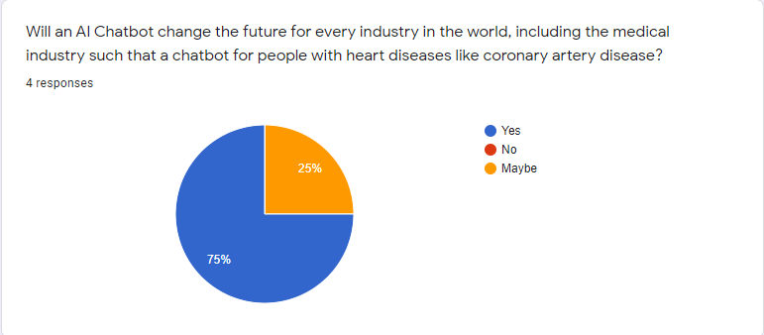

Figure : User acceptance (Future and chatbot for heart disease)

As you can the above chart shows that 75% casted a ballot yes and 25 percent casted a ballot maybe and 0 percent casted a ballot no. This implies that an artificial intelligence chatbot will change the future for each industry on the planet including the clinical business.

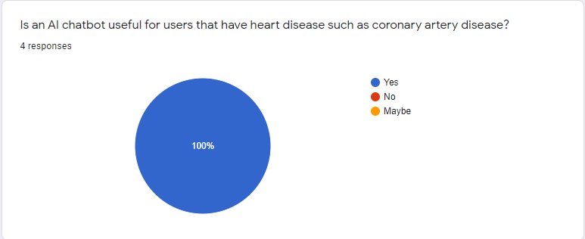

Figure : User acceptance (Useful chatbot for heart disease)

As you can see the diagram above it shows that 100% casted a ballot yes. This implies that individuals concur that a computer-based intelligence chatbot is valuable for individuals that have any heart conditions.

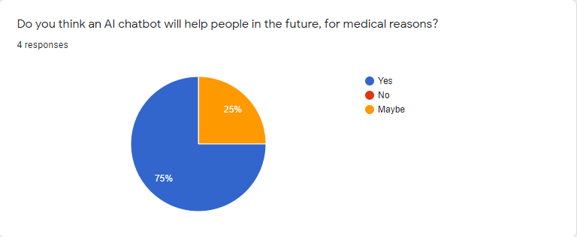

Figure : User acceptance (AI and Surgery)

From the image above, you can see that 75% casted a ballot indeed, 25% casted a ballot perhaps and 0 percent casted a ballot no. This implies that individuals concur that a man-made intelligence chatbot can assist individuals with clinical issues later on.

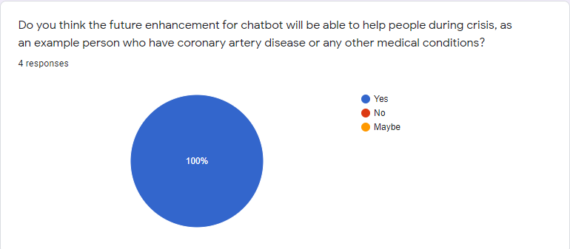

Figure : Figure 54: User acceptance (Crisis and chatbot)

As you can see from the graph over, 100% casted a ballot yes for this inquiry. This implies that individuals concur that the future upgrade of an artificial intelligence chatbot can help individuals during emergency, as an illustration an individual who have coronary conduit illness.

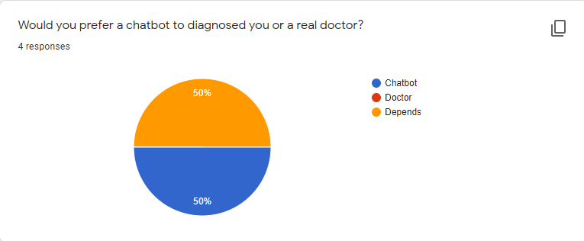

Figure : Figure 54: User acceptance (Chatbot insteadof doctor)

Concerning this graph 50% casted a ballot chatbot and 50 percent casted a ballot specialist. For this inquiry, as I would like to think a few group are ot prepared to set the asnwer as chatbot bacause they are as yet sorting out whether a simulated intelligence chatbot can be confided in more than specialists.

# **Conclusion:**

## **Challenges:**

One of the difficulties that I need to confront while carrying out the chatbot is making the outflow of feelings on the chatbot, this is on the grounds that at first it was truly elusive the right articulation for each inquiry or questions that the client will ask the chatbot. For instance, when the client input hi the chatbot will welcome back by making proper acquaintance cheerfully on the chatbot's face. Other than that, another test that I need to go through is making expected inquiries for clients when they pose inquiries that they need to ask, presently the critical step about this is I don't have the foggiest idea what kind of inquiries to anticipate from the client, so I needed to make do by contributing however many questions as I can consider from what the client will enter.

With every creation, there must be challenges in order to create the best form of product. During the process of creating the chatbot, many obstacles had to be overcome, one of which were the amount of enquiries that the chatbot could answer. Due to the fact that the I am not a certified or professional doctor, I cannot not answer every single question that pregnant women may ask when using the chatbot. In this case, the chatbot cannot help pregnant patients with very specific questions, or rare cases during pregnancy which will in turn cause the chatbot not to give an answer, but instead read a command that states it does not have an opinion on that matter. With this in mind, the patient may need to consult a doctor in order to answer their questions and thoughts.

Another challenge that I faced was during the implementation of the chatbot was the questions that had to be thought during the creation of the chatbot. The chatbot may miss a question that was rephrased in a certain way, meaning the chatbot may have the solution of a question however, it may not be able to give it, since the chat bot might not be able to interpret what the patient has asked.

Other than that, the language of the chatbot may not be preferred by the patient (user). I had to ensure that the chatbot was very friendly and did not cause any users to be offended or annoyed by the chatbot. I resorted to using a female voiced narrator in order to make the users have a more pleasant experience with the chatbot.

## **Future Enhancement:**

One of the suggested future improvements is that the chatbot can make looks without us client or supervisor contributing it ourselves in light of the fact that there is a ton work to be done just by doing the articulation ourselves. Other than that, I would suggest that the chatbot would have the entirety of the distinctive culture of varieties there is on the planet, the explanation I'm suggesting this is so when individuals all around the world uses the chatbot they would feel cheerful, invigorated or some other great feelings while utilizing the chatbot on the grounds that they are incorporated regardless their identity, religion or country they are from. To wrap things up, I might want to suggest that the chatbot would consequently have a decent presentation when opening the chatbot or application. The chatbot can make a presentation about itself, of what it does, does and how it can manage that assistance of clients.

Include different languages

The main purpose of this recommendation is to ensure that the chatbot is more diverse, and user friendly to other patients that may have a lack of understanding towards the standard language to the chatbot (English). This will allow the chat bot to be utilized everywhere and be easily understood by the users. Here, in Malaysia, the main language that is communicated between individuals is Malay. Due to this fact, in the future, the Malay language may be added to the chat bot’s language, allowing more users to be served and treated.

Include connection to chat bot

In order to allow users to receive the answers to their enquiries that the chat bot may not be able to answer quickly, but accurately, the chatbot can be connected directly to a medical professional, in order to answer their questions, quite similar to a customer service center. With this method, the user may be connected with a more helpful source of information. It will also help users feel more satisfied as the health professional can make the user understand their situation clearer.

Elaborate explanations

With the chatbot being used for some time in the future, the amount of information that is gathered from each user using the chatbot can be used as a reference for future problems that may be asked. Since the world is always changing, more things will be discovered as time passes on, leading to a more branch of problems to be answered by pregnant patients. Without the update of answers and questions, the chatbot will sooner or later be less useful to pregnant patients. With this in mind, the chatbot must increase its credibility by being able to answer more questions. More data data storage may be needed as more questions may be asked.

# **References**

sunwaymedical. (n.d.). *"I Care, I am Reliable, I Make a Difference"* . Retrieved from sunwaymedical: https://www.sunwaymedical.com/about-us/

Angers, L. (2020, 08 28). *5 Major Depression Symptoms And How To Treat Them* . Retrieved from Betterhelp: https://www.betterhelp.com/advice/depression/5-major-depression-symptoms-and-how-to-treat-them/?utm_source=AdWords&utm_medium=Search_PPC_c&utm_term=_b&utm_content=118051369567&network=g&placement=&target=&matchtype=b&utm_campaign=11771068538&ad_type=text&

Mayoclinic. (n.d.). *Depression (major depressive disorder)*. Retrieved from Mayoclinic: https://www.mayoclinic.org/diseases-conditions/depression/symptoms-causes/syc-20356007

Clarke, J. (2020, 01 24). *Can Artificial Intelligence Help With Depression?* . Retrieved from Verywellmind: https://www.verywellmind.com/can-artificial-intelligence-help-depression-4158330

Aitskadapa. (n.d.). *Do you know Artificial Intelligence (AI) can now detect anxiety and depression in children?* . Retrieved from aitskadapa: https://aitskadapa.ac.in/Do-you-know-Artificial-Intelligence-can-now-detect-anxiety-and-depression-in-children

stevens. (2021, 02 28). *Detecting Depression, Using AI* . Retrieved from stevens: https://www.stevens.edu/news/detecting-depression-using-ai

Bunge, G. D.-B.-N.-C.-M.-E. (2020, 11). *Artificial Intelligence Chatbot for Depression: Descriptive Study of Usage* . Retrieved from researchgate: https://www.researchgate.net/publication/347216700_Artificial_Intelligence_Chatbot_for_Depression_Descriptive_Study_of_Usage

Baumeistera, E. B.-T. (2019, 08 20). *The Next Generation: Chatbots in Clinical Psychology and Psychotherapy to Foster Mental Health – A Scoping Review.* Retrieved from karger: https://www.karger.com/Article/Pdf/501812

mayoclinic. (n.d.). *Depression (major depressive disorder)*. Retrieved from mayoclinic: https://www.mayoclinic.org/diseases-conditions/depression/symptoms-causes/syc-20356007

Chris Iliades, M. (2011, 06 22). *5 Questions Doctors Ask When Screening for Depression* . Retrieved from everydayhealth: https://www.everydayhealth.com/depression/5-questions-doctors-ask-when-screening-for-depression.aspx

Browne, D. (2020, 06 26). *Do Mental Health Chatbots Work?* Retrieved from healthline: https://www.healthline.com/health/mental-health/chatbots-reviews

e-bot7. (n.d.). *The 7 characteristics of a good chatbot* . Retrieved from e-bot7: https://e-bot7.com/the-7-characteristics-of-a-good-chatbot/

Debecker, A. (2017, 08 31). *How to Perform a Chatbot Review* . Retrieved from blog.ubisend: https://blog.ubisend.com/optimise-chatbots/chatbot-review

Duersch, C. (2018, 04 17). *Replika Review: This thing is Smart, Sexy, Creepy, and Overall Cool* . Retrieved from medium: https://medium.com/@cdtommy/replika-review-this-thing-is-smart-sexy-creepy-and-overall-cool-1655d84e626

Metz, C. (2020, 06 16). *Riding Out Quarantine With a Chatbot Friend: ‘I Feel Very Connected’* . Retrieved from nytimes: https://www.nytimes.com/2020/06/16/technology/chatbots-quarantine-coronavirus.html

Ta V, G. C. (2019). User Experiences of Social Support From Companion Chatbots in Everyday Contexts: Thematic Analysis. *JOURNAL OF MEDICAL INTERNET RESEARCH*, 10.

Solé, B. J.-M.-A. (2017). Cognitive Impairment in Bipolar Disorder: Treatment and Prevention Strategies. *international journal of neuropsychopharmacology*, 670–680.

Holland, K., & Nicholls, E. (2018, January 18). Everything You Need to Know About Bipolar Disorder. Retrieved August 16, 2021, from https://www.healthline.com/health/bipolar-disorder

Jennifer Casarella, M. (2020, September 27). Bipolar Diagnosis. Retrieved from https://www.webmd.com/bipolar-disorder/guide/bipolar-disorder-diagnosis

Piotr, Z., Furmankiewicz, M., & Piorunkiewicz, A. S. (2014). E-health artificial intelligence system implementation: case study of knowledge management dashboard of epidemiological data in Poland. *INTERNATIONAL JOURNAL OF BIOLOGY AND BIOMEDICAL ENGINEERING*, 164-171.

Darlington, K. W. (2011). Designing for Explanation in Health Care Applications of Expert Systems. *SAGE Open*. doi:https://doi.org/10.1177/2158244011408618

Heckerman, D. E. (1989). The Pathfinder System. *Proceedings of the Annual Symposium on Computer Application in Medical Care*, 203-207.

Fuchs, J. (1999). CaDet, a Computer-Based Clinical Decision Support System for Early Cancer Detection. *International Society for Preventive Oncology*, 78-87.

Adamopoulou, E., & Moussiades, L. (2020). An Overview of Chatbot Technology. *IFIP International Conference on Artificial Intelligence Applications and Innovations*, 373-383.

Puwar, G. (2018, October 4). *Chat bots Case Study:*. Retrieved from Medium: https://medium.com/@gpuwar1/chat-bots-case-study-3bc6f3f59320

Tan, S. (2020, 08 14). *Ultimate Guide to Kakao for Business*. Retrieved from resond.io: https://respond.io/blog/kakao-for-business

my.clevelandclinc. (n.d.). *Coronary Artery Disease* . Retrieved from my.clevelandclinc: https://my.clevelandclinic.org/health/diseases/16898-coronary-artery-disease

clevelandclinic. (n.d.). *Depression Medicines*. Retrieved from clevelandclinic.

Chung, K. (2021, 03). *A Chatbot for Perinatal Women's and Partners' Obstetric and Mental Health Care: Development and Usability Evaluation Study*. Retrieved from researchgate.net: https://www.researchgate.net/publication/349913462_A_Chatbot_for_Perinatal_Women%27s_and_Partners%27_Obstetric_and_Mental_Health_Care_Development_and_Usability_Evaluation_Study

Chung, K. (2021, 02). *A Chatbot for Perinatal Women’s and Partners’ Obstetric and Mental Health Care: Development and Usability Evaluation Study.* Retrieved from sementicscholar.org: https://www.semanticscholar.org/paper/A-Chatbot-for-Perinatal-Women%E2%80%99s-and-Partners%E2%80%99-and-Chung-Cho/f5b2a2199eada593f0ac3c3578c07101cf7e8a84

(n.d.). Retrieved from screenskills.com: https://www.screenskills.com/starting-your-career/job-profiles/games/programming/artificial-intelligence-ai-programmer/

(n.d.). Retrieved from forbes.com: https://www.forbes.com/sites/shourjyasanyal/2018/10/27/4-ways-in-which-ai-is-revolutionizing-cardiac-care/?sh=91076947a431

(n.d.). Retrieved from botscrew.com: https://botscrew.com/blog/what-are-bots/

(n.d.). Retrieved from https://www.facebook.com/vvishnus,2018

(n.d.). Retrieved from bigdata-madesimple: https://bigdata-madesimple.com/how-do-chatbots-work-an-overview-of-the-architecture-of-a-chatbot/

(n.d.). Retrieved from bigdata-madesimple.com: https://bigdata-madesimple.com/how-do-chatbots-work-an-overview-of-the-architecture-of-a-chatbot/

(n.d.). Retrieved from semanticsscholar.org: https://www.semanticscholar.org/paper/Doctor-Chatbot-%3A-Heart-Disease-Prediction-System-Fernandes-Gawas/c4555fbecc6d829067026b2b8034dcf892647cbc

(n.d.). Retrieved from semanticscholar.org: https://www.semanticscholar.org/paper/Doctor-Chatbot-%3A-Heart-Disease-Prediction-System-Fernandes-Gawas/c4555fbecc6d829067026b2b8034dcf892647cbc

(n.d.). Retrieved from semanticscholar.org: https://www.semanticscholar.org/paper/Doctor-Chatbot-%3A-Heart-Disease-Prediction-System-Fernandes-Gawas/c4555fbecc6d829067026b2b8034dcf892647cbc

(n.d.). Retrieved from semanticscholar.org: https://www.semanticscholar.org/paper/Doctor-Chatbot-%3A-Heart-Disease-Prediction-System-Fernandes-Gawas/c4555fbecc6d829067026b2b8034dcf892647cbc

(n.d.). Retrieved from semanticscholar.org: https://www.semanticscholar.org/paper/Doctor-Chatbot-%3A-Heart-Disease-Prediction-System-Fernandes-Gawas/c4555fbecc6d829067026b2b8034dcf892647cbc

(n.d.). Retrieved from semanticscholar.org: https://www.semanticscholar.org/paper/Doctor-Chatbot-%3A-Heart-Disease-Prediction-System-Fernandes-Gawas/c4555fbecc6d829067026b2b8034dcf892647cbc

(n.d.). Retrieved from semanticscholar.org: https://www.semanticscholar.org/paper/Doctor-Chatbot-%3A-Heart-Disease-Prediction-System-Fernandes-Gawas/c4555fbecc6d829067026b2b8034dcf892647cbc

(n.d.). Retrieved from semanticscholar.org: https://www.semanticscholar.org/paper/Doctor-Chatbot-%3A-Heart-Disease-Prediction-System-Fernandes-Gawas/c4555fbecc6d829067026b2b8034dcf892647cbc

(n.d.). Retrieved from semanticscholar.org: https://www.semanticscholar.org/paper/Doctor-Chatbot-%3A-Heart-Disease-Prediction-System-Fernandes-Gawas/c4555fbecc6d829067026b2b8034dcf892647cbc

(n.d.). Retrieved from semanticscholar.org: https://www.semanticscholar.org/paper/Doctor-Chatbot-%3A-Heart-Disease-Prediction-System-Fernandes-Gawas/c4555fbecc6d829067026b2b8034dcf892647cbc

(n.d.). Retrieved from semanticscholar.org: https://www.semanticscholar.org/paper/Doctor-Chatbot-%3A-Heart-Disease-Prediction-System-Fernandes-Gawas/c4555fbecc6d829067026b2b8034dcf892647cbc

Cleveland Clinic. 2021. *Coronary Artery Disease: Causes, Symptoms, Diagnosis & Treatments*. [online] Available at: <https://my.clevelandclinic.org/health/diseases/16898-coronary-artery-disease> [Accessed 18 August 2021].

2021. [online] Available at: <https://www.screenskills.com/starting-your-career/job-profiles/games/programming/artificial-intelligence-ai-> [Accessed 18 August 2021].

2021. [online] Available at: <https://www.semanticscholar.org/paper/Doctor-Chatbot-%3A-Heart-Disease-Prediction-System-Fernandes-Gawas/c4555fbecc6d829067026b2b8034dcf892647cbc [Accessed 10 Aug. 2021].> [Accessed 18 August 2021].

Sanyal, S., 2021. *4 Ways In Which AI Is Revolutionizing Cardiac Care*. [online] Forbes. Available at: <https://www.forbes.com/sites/shourjyasanyal/2018/10/27/4-ways-in-which-ai-is-revolutionizing-cardiac-care/?sh=3430f7317a43> [Accessed 18 August 2021].

2021. [online] Available at: <https://bigdata-madesimple.com/how-do-chatbots-work-an-overview-of-the-architecture-of-a-chatbot/.> [Accessed 18 August 2021].

BotsCrew. 2021. *What Are Bots? How Do Chatbots Work? - BotsCrew*. [online] Available at: <https://botscrew.com/blog/what-are-bots/#:~:text=Chatbot%20or%20bot%20%E2%80%93%20is%20a.> [Accessed 18 August 2021].

Cleveland Clinic. 2021. Coronary Artery Disease: Causes, Symptoms, Diagnosis &

Pdfs.semanticscholar.org. 2021. [online] Available at: <https://pdfs.semanticscholar.org/4b76/c29d3f8c59ce50ee862cc7c9177eabd0d4dc.pdf?_ga=2.157144441.357660572.1629456512-1808933762.1628143605> [Accessed 14 August 2021].

Chung, K., Cho, H. and Park, J., 2021. *A Chatbot for Perinatal Women’s and Partners’ Obstetric and Mental Health Care: Development and Usability Evaluation Study*. [online] A Chatbot for Perinatal Women’s and Partners’ Obstetric and Mental Health Care: Development and Usability Evaluation Study. Available at: <https://www.ncbi.nlm.nih.gov/pmc/articles/PMC7970298/> [Accessed 13 August 2021].

# Sofbang. 2021. What are AI Chatbots and How Do They Work? | Sofbang. [online] Available at: <https://www.sofbang.com/blog/what-are-ai-chatbots-and-how-do-they-work/> [Accessed 20 August 2021].

Topics, H., 2021. Health Problems in Pregnancy | Gestational Diabetes| MedlinePlus. [online] Medlineplus.gov. Available at: <https://medlineplus.gov/healthproblemsinpregnancy.html> [Accessed 20 August 2021].

Gupta, V., 2021. How Do Chatbots Work?. [online] Internet Marketing Blog. Available at: <https://www.vineetgupta.net/how-do-chatbots-work/> [Accessed 20 August 2021].

(COVID-19), C., Health, E., Disease, H., Disease, L., Management, P., Conditions, S., Problems, S., Disorders, S., Checker, S., Blogs, W., Answers, Q., Guide, I., Doctor, F., A-Z, C., A-Z, S., Drugs, C., Pregnant, T., Medications, M., Identifier, P., Interactions, C., Tool, D., Management, D., Obesity, W., Recipes, F., Exercise, F., Beauty, H., Balance, H., Relationships, S., Care, O., Health, W., Health, M., Well, A., Sleep, H., Teens, H., Pregnant, G., Trimester, F., Trimester, S., Trimester, T., Baby, N., Health, C., Vaccines, C., Kids, R., Cats, H., Dogs, H., Updates, C., Updates, C., Experts, C., Hospitals Running Out of ICU Beds, E., Within, H., Blogs, W. and Center, N., 2021. Eating Right While Pregnant. [online] WebMD. Available at: <https://www.webmd.com/baby/guide/eating-right-when-pregnant#1> [Accessed 20 August 2021].

Byram Healthcare. 2021. 7 Lifestyle Changes to Make Now That You&#039;re Pregnant. [online] Available at: <https://breastpumps.byramhealthcare.com/blog/2019/08/26/healthy-lifestyle-changes-pregnant> [Accessed 20 August 2021].

Plannedparenthood.org. 2021. *Do I Need to Change My Lifestyle Before I Get Pregnant?*. [online] Available at: <https://www.plannedparenthood.org/learn/pregnancy/pre-pregnancy-health/should-i-change-my-lifestyle-when-i-am-planning-pregnancy> [Accessed 14 August 2021].

Respond.io. 2021. *Kakao for Business: The Ultimate Guide to KakaoTalk Channel*. [online] Available at: <https://respond.io/blog/kakao-for-business> [Accessed 20 August 2021].

# **Appendices**

## Source codes of the chatbot:

Eslam Magdy Rezk Ebrahim Hassanin(TP062816):

KnowledgeBase Info:

Author:

Author's Website:

Copyright:

License:

Creation Date: 2/8/2021 1:02:39 AM

Last Update Date: 16/8/2021 1:22:10 AM

Rating: Unknown

Rating Description:

Category: Other

Language: English

Comment: Describe your KnowledgeBase here

Rules:

Rule Name: Mainmenu

Input Text: 1

Output Text: You can chat me, without pressing any number if you need.

- Treatment course press O

- More information about depression. Press 2

- To know whether you have depression or not. Press 3

- What are the medications work and what are the side effects of the disease? Press 4

- Conversation about depression? Press 5

- For Help. Press H

Exit. Press 9

Rule Name: _startup

Input Text: _startup

Output Text: I am your friend Dr. Yesla, I will help you to know if you are depressed or not, you can talk to me at any time, you are welcome here in your place

Hello! whats your name?

Rule Name: conversation

Input Text: 5

Output Text: how are you ?

Rule Name: Q0

Input Text: *

Output Text: My name is Dr.Yesla, I will help you at any time, Whats your name?

Rule Name: Q00

Input Text: my name is [name]

Input Text: [name]

Input Text: hi iam [name]

Output Text: Hello [name], I'm your medical assistant for depression. We can talk together about anything you want to tell me, okay?

Rule Name: Q1

Input Text: *

Output Text: Don't worry we are with you, what is your question?

Output Text: I am your good friend and I want to know what your problem is ?

Output Text: What do you want to know my friend?

Rule Name: Q2

Input Text: *

Output Text: Listen [name] , I need to let yo know that the depression is a very famous and common disease, depression can cause a lot of psychological disorders, loss of interest in everything, love of isolation and distance from people and affect the way you think and feel for those around you and lead to the inability to do anything, whether at work or study, so what are your symptoms?

Rule Name: Q3

Input Text: *

Output Text: Well, I understood what you are saying. If you have all these symptoms, you suffer from depression, or if some of them are, you should do an EEG and check if you are sick or not. Have you ever taken depression medications without referring to the doctor?

Rule Name: Q4

Input Text: *

Output Text: If you have taken antidepressants before, you may experience drowsiness, low blood pressure, loss of appetite and other sexual problems, but if you don't, you may be fine, so what was the most difficult misfortune you faced in your life and when was it?

Rule Name: Q5

Input Text: *

Output Text: The most important thing is that everything is fine now, but how long have you been sad?

Rule Name: Q6

Input Text: *

Output Text: Well, you can do a simple thing also that will help you get out of your psychological state, you can write down all the happy moments that happened in your life in a note on your computer or mobile and in the evening read and review them, and do not write anything sad, to open the note you can write ( notepad), after the end of our conversation.

But now all you should avoid is that you should not take any depression medication without consulting a doctor and without examination, because it has serious side effects, and you should always go outside and always go on trips, take advantage of opportunities and you must find solutions in life to treat sadness And the first rule is don't talk or think about anything sad, see you in another meeting,

Rule Name: End

Input Text: *

Output Text: Main menu 0

Exit 9

Rule Name: exit

Input Text: 9

Input Text: exit

Input Text: Exit

Input Text: Close

Input Text: close

Input Text: shut down

Input Text: bye

Input Text: good bye

Output Text: <exit>

Rule Name: InformationAboutDepresion

Input Text: 2

Output Text: Listen my friend, depression is a very famous and common disease, depression can cause a lot of psychological disorders, loss of interest in everything, love of isolation and distance from people and affect the way you think and feel for those around you and lead to the inability to do anything, whether at work or study.

Press 0 To back to the Main menu.

Exit. press 9

Rule Name: Unique

Input Text: *

Output Text: Sorry I didn't understand what you say.

Main menu 0

Exit 9

Output Text: You didn't choose from the options,please determine your choice

Main menu 0

Exit 9

Output Text: If you need help, you may need to go to the main menu

Main menu 0

Exit 9

Output Text: Please try again [name]

Main menu 0

Exit 9

Output Text: Please speak with me about the main topic is the deprresion, how can I help you ?

Main menu 0

Exit 9

Output Text: Sorry, Please ask another question

Output Text: That's very intersting! Wow

Rule Name: note

Input Text: notepad

Output Text: Opening notepad.

|Cmd: notepad

Rule Name: Greetings

Input Text: (hi)

Input Text: (hello)

Input Text: (hey)

Output Text: Hello, I hope you are fine

You can speak with me, without pressing any number if you need.

- Treatment course press O

- More information about depression. Press 2

- To know whether you have depression or not. Press 3

- What are the medications work and what are the side effects of the disease? Press 4

- Conversation about depression? Press 5

- For Help. Press H

Exit. Press 9

Rule Name: Conversationuser

Input Text: (speak)

Input Text: (tell)

Input Text: (chat)

Input Text: (text you)

Output Text: <send 5>

Rule Name: ChatbotName

Input Text: (Your Name)

Output Text: My name is doctor yesla! and you ?

Rule Name: UserName

Input Text: (my name)

Output Text: Nice to meet you

Rule Name: chatbotAGE

Input Text: (old are you)

Input Text: (your age)

Input Text: (years you lived)

Output Text: I'm 22 years old

Rule Name: SymptomsDepression

Input Text: (symptoms)

Input Text: (symptom)

Input Text: (sympto)

Input Text: (symp)

Input Text: (sympt)

Output Text: Symptoms of depression include depressive mood, loss of pleasure, fatigue, loss of self-confidence and loss of self-esteem, self-criticism with reasonable causes, feelings of coldness, psychological retardation

Rule Name: MedicationsChat

Input Text: (top medication)

Input Text: (best medication)

Input Text: (prefer medications)

Input Text: (take medications)

Input Text: (best medications)

Input Text: (top medications)

Input Text: (take medication)

Input Text: (prefer medication)

Input Text: (advice medications)

Input Text: (advice medication)

Input Text: (tell medications)

Input Text: (tell medication)

Output Text: There are top 10 popular medications for deprerssion like setraline, fluoxetine, citalopram, escitalopram, paroxetine, fluvoxamine, desvenlafaxine, duloxetine, levomilnacipran, and venlafaxine.

Main menu 0

Exit 0

Rule Name: SideEffectsChat

Input Text: side effect

Input Text: side effects

Output Text: There are many of side effects of medications for depression like nausea, trouble sleeping, nervousness, tremors, sexual problems, dry mouth, fatigue, drowsiness, and constipation

Rule Name: TakeUser

Input Text: (take medication)

Output Text: Medications for depression must be taken under the guidance of the doctor, because in the event of any error, or the disease is dealt with individually, or the wrong diagnosis will occur, defects and complications will occur.

Rule Name: BadFeelingsUser

Input Text: hate (you)

Input Text: don't love (you)

Input Text: (you) strange

Output Text: Why you don't love me ? I need to help you.

Output Text: I'm beside you all time, don't hate me and don't worry.

Rule Name: GoodFeelingsUser

Input Text: love (you)

Input Text: adore (you)

Input Text: love (me)

Input Text: feel good

Input Text: feel (good)

Input Text: feel (fine)

Input Text: feel (perfect)

Input Text: feel comfortable

Output Text: I love you

Output Text: I adore you

Rule Name: NameFUser

Input Text: I'm [name]

Input Text: (my name is) [name]

Output Text: Hello [name], I hope you are fine

You can speak with me, without pressing any number if you need.

- Treatment course press O

- More information about depression. Press 2

- To know whether you have depression or not. Press 3

- What are the medications work and what are the side effects of the disease? Press 4

- Conversation about depression? Press 5

- For Help. Press H

Exit. Press 9

Rule Name: WhenAsk

Input Text: when

Output Text: I will manage this and tell you the date

Rule Name: HowAsk

Input Text: how are you

Output Text: I'm fine thanks

Rule Name: LetAsk

Input Text: (let me)

Output Text: Okay, but if you need any help tell me

Rule Name: WebsitesDepression

Input Text: know (video)

Input Text: find (video)

Input Text: send(video)

Input Text: attach (video)

Input Text: provide (video)

Input Text: attach (website)

Input Text: find (website)

Input Text: know (website)

Input Text: send (website)

Input Text: provide (website)

Input Text: any (website)

Input Text: any (video)

Input Text: (video)

Input Text: (websites)

Output Text: These are many of URL for websites and videos will help you and provide you with all informations:

https://www.health.com/condition/depression/8-helpful-websites-for-coping-with-depression

https://www.verywellmind.com/best-online-help-for-depression-4691259

https://www.aia.com.my/en/what-matters/seetheotherside/mental-health-helpline-resources.html

Rule Name: GoodFunc

Input Text: (good)

Input Text: (pretty)

Input Text: (aswesome)

Input Text: (wonderful)

Input Text: (perfect)

Input Text: (beautiful)

Output Text: Yeah, I know

Output Text: Lol

Output Text: it seems like this.

Output Text: yeah,not bad

Rule Name: JobDr

Input Text: (your) job

Input Text: work (me)

Input Text: serve (me)

Input Text: servant

Output Text: I'm working for you by helping you to provide the informations and everthing about depression to you.

Rule Name: GameDr

Input Text: (game)

Input Text: (quiz)

Input Text: (games)

Output Text: I have a funny game like small quiz and I need you to join us, lets start!

You can detect that if you have a depression or not!

1- Do you feel fulfilled by the activities that were fun ?

Rule Name: Quiz1

Input Text: *

Output Text: Do you feel fulfilled by the activities that were fun ?

Rule Name: Quiz 2

Input Text: *

Output Text: Do you always feel sad ?

Rule Name: Quiz 3

Input Text: *

Output Text: Do you feel unable to perform daily activities for more than two weeks ?

Rule Name: Quiz 4

Input Text: *

Output Text: Do you suffer from a loss of energy ?

Rule Name: Quiz 5

Input Text: *

Output Text: Are you thinking of self-harm or suicide ?

Rule Name: Quiz 6

Input Text: *

Output Text: What are the behaviors or language that you had in the last period in which you noticed that you are depressed?

Rule Name: Quiz 7

Input Text: *

Output Text: If you have all of these symptoms, you must go to the nearest doctor immediately so that the disease does not develop, especially if these symptoms persist for more than two weeks, but if it is one or two, you must follow up and if there are no developments, you are healthy.

Main menu. Press 0

Exit 9

Rule Name: HowPatient

Input Text: (how)

Output Text: press 5 to make a conversation with chatbot to increase your knowledge

Rule Name: MyAge

Input Text: (I'm years)

Output Text: nice

Rule Name: ManageYourDepression

Input Text: 3

Output Text: In the beginning, depression was diagnosed through blood analysis or complex tests, but that was because the physical examination diagnoses the general condition of the patient, but we must talk to you by questioning you with some questions such as what is your psychological state and mood and some questions about behaviors, feelings, weight loss and transformation Everything from love to hate and planning to suicide, it may also be difficult for us to diagnose depression easily because there are some patients who are in a careless state and others are in a very nervous situation.

main menu 0

Exit 9

Rule Name: InformationMenu

Input Text: 4

Output Text: All medications for depression are used under the doctor's instructions, and they help and balance neurotransmitters, which are substances responsible for communication between the brain such as serotonin and dopamine. So, antidepressants can remain in the human body for 36 hours or more. Before talking about the side effects, you must be absolutely sure that all the side effects disappear immediately after stopping taking the drug, and some of these side effects are sexual problems, nausea, vomiting and constant drowsiness.

Main menu 0

Exit 9

Rule Name: Help

Input Text: H

Output Text: - Save depressed people from suicide. Press S

- More videos. Press V

Back to the Main meu. Press 0

Exit. Press 9

Rule Name: Happen

Input Text: what happen

Output Text: If you need more information about how the depression and medictions go on press 5

Main menu 0

Exit 9

Rule Name: Treatment

Input Text: o

Output Text: Hi [name] , here I can help you to get and provide you many of advices that will help you get cured of the disease early, so are you have a person to talk with him ?

Back to the main menu. press 0

Exit 9

Rule Name: Treatment1

Input Text: *

Output Text: Listen carfully [name] , In the beginning, you should know that depression is not a psychological problem or a flaw in your personality, but you should know that it is a medical problem like any problem, for example, a cold or headache, all people are exposed to this disease and not only you, my friend, so you must understand this well, So have you ever gone to a specialist?

Rule Name: Treatment2

Input Text: *

Output Text: Yes, going to someone who specializes in this field will help you a lot to improve your condition and recover fully as long as you have the strength and will to do so. How is your day likely going?

Rule Name: Treatment3

Input Text: *

Output Text: I always want to help you my friend, you should sit with your family as much as possible and organize with a specialist in this matter and stick to your country and you will find a great improvement in your life, the matter is very simple. This is how it is now explained.

Backto the main menu. Press 0

Exit 9

Rule Name: BackToMenu

Input Text: 0

Output Text: <send 1>

Rule Name: SuicideHelp

Input Text: S

Output Text: People with depression are more likely to commit suicide, if you have a friend or someone close to you who has this disease, you should try to get close to him and help him so that he does not do anything to himself, and you must talk to a lot and know what he plans on what is going on in his mind towards the idea of ??suicide, and if he has And you must advise his family about what is going on and how to deal with him and you must always make sure that the person lives in a safe environment, and that all members of the home must be near him at all times, and if possible and find the hotline that exists within your country for depression and suicide, it must be used in Cases of danger and contact the number.

Back to the Main menu. Press 0

Back to Help menu. Press M

Exit 9

Rule Name: HelpMenu

Input Text: M

Output Text: <send H>

Rule Name: MoreVideos

Input Text: V

Output Text: Main menu. Press 0

Back to Help menu. Press M

Exit 9

|Cmd: https://l.facebook.com/l.php?u=https%3A%2F%2Fwww.youtube.com%2Fwatch%3Fv%3D8Su5VtKeXU8%26fbclid%3DIwAR290Pu6ecqsj4iue-dNSjuDRtVjy0NqaC8lAn6oEjwVazmmgKKDjzwWpKE&h=AT0pKKcaXty7hrXKVcFCJfk6GJ-zYhquibaO87FzsLpfn1bcXDXH3zJI47PzXPTPxGAqjB5mYjgkXK5xSXnhHQUi7txYfzxFfRtok1xl7Hy2z-AiJ0csV4nawv-WZVxb9x_0Bg

Rule Name: WhatName

Input Text: what my name

Output Text: Your name is [name]

Adryana Marzookhy Binti Azhar(TP062520):

KnowledgeBase Name: C:\Users\user\Downloads\coronary for verbots.vkb

KnowledgeBase Version: 1.0

KnowledgeBase Build: 129

KnowledgeBase Info:

Author:

Author's Website:

Copyright:

License:

Creation Date: 7/7/2021 9:57:07 PM

Last Update Date: 20/8/2021 11:30:13 AM

Rating: Unknown

Rating Description:

Category: Other

Language: English

Comment: Describe your KnowledgeBase here

ResourceFiles:

Default.vrp

Default.vsn

Rules:

Rule Name: coronary

Input Text: 1

Input Text: coronary

Input Text: coronary artery disease

Input Text: what is coronary artery disease

Output Text: Coronary artery disease is the buildup of plague in the arteries that supply oxygen-rich blood to your heart. Plague causes a narrowing or blockage that could result in a heart attack. Symptoms include chest pain or discomfort and shortness of breath. Treatments include lifestyle changes and medications that target your risk factors and/or possible surgery.

Rule Name: _startup

Input Text: _startup

Input Text: 0

Input Text: hi

Input Text: hello

Input Text: whatsup

Input Text: hey

Input Text: hey bro

Input Text: haha

Input Text: ey

Input Text: yello

Input Text: heyyo

Input Text: heyo

Input Text: yello

Input Text: yelo

Output Text: Hello there. :-)

Output Text: Hey. :-)

Output Text: How are you doing. :-)

Output Text: Hi, nice to meet you. :-)

Output Text: Whatsup. :-)

Rule Name: whogetscoronary

Input Text: 2

Input Text: who gets coronary

Input Text: who gets coronary artery disease

Input Text: who can get coronary artery disease

Input Text: who can get coronary artery disease.

Input Text: who can get coronary artery disease?

Input Text: Who can get coronary artery disease

Input Text: Who can get coronary artery disease.

Input Text: Who can get coronary artery disease?

Input Text: how can someone get coronary artery disease

Input Text: how can someone get coronary artery disease.

Input Text: how can someone get coronary artery disease?

Input Text: How can someone get coronary artery disease

Input Text: How can someone get coronary artery disease.

Input Text: How can someone get coronary artery disease?

Output Text: People who have a high cholesterol level, high blood pressure, family history of heart disease, have diabetes, are a smoker, are overweight and are physically inactive.

Rule Name: symptoms

Input Text: 3

Input Text: symptoms of coronary

Input Text: what are the symptoms of coronary artery disease

Input Text: symptoms of coronary artery disease

Input Text: what are the symptoms

Input Text: symptoms

Input Text: symptoms?

Input Text: Symptoms

Input Text: Symptoms?

Output Text: The most common symptoms are chest pains or shortness of breath, especially after light physical activity like walking up the stairs, but even at rest. Sometimes you won’t know you have coronary artery disease until you have a heart attack. Symptoms of a heart attack includes chest discomfort, pressure, aching, burning, numbness, fullness, squeezing or dull ache, feeling tired, dizziness, lightheaded, nausea, weakness. Symptoms for women can be slightly different that is discomfort or pain in the shoulder, feeling indigestion or heartburn, unexplained anxiety and cold sweat.

Rule Name: diagnosed

Input Text: 4

Input Text: diagnosed

Input Text: how is coronary artery diagnosed

Input Text: what are the diagnostics

Input Text: what are the diagnostics for coronary artery disease

Input Text: Diagnosed

Input Text: how is coronary artery diagnosed?

Input Text: what are the diagnostics?

Input Text: What are the diagnostics

Input Text: What are the diagnostics?

Input Text: what are the diagnostics for coronary artery disease?

Input Text: What are the diagnostics for coronary artery disease

Input Text: What are the diagnostics for coronary artery disease?

Input Text: diagnostics

Input Text: diagnostics?

Input Text: Diagnostics?

Input Text: Diagnostics

Output Text: Diagnostic tests include an (EKG) test, this test records the electrical activity of the heart, can detect heart attack, schemia and heart rhythm issues. Next is exercise stress test, this treadmill test to determine how well your heart functions when its working the hardest, it can detect angina and coronary blockage. Other than that, there is echocardiogram, this test uses sound waves to see how well structures of your heart are working and overall functions of your heart. Lastly there is cardiac catherization, this test involves inserting small tubes into the blood vessels of the heart to evaluate heart function including the presence of coronary artery disease.

Rule Name: whattodo

Input Text: 5

Input Text: what to do if i have symptoms of coronary artery disease

Input Text: what should i do if i have symptoms of coronary artery disease

Output Text: You need to seek immediate help, if a blood clot in a coronary artery has broken loose and moved into your brain, it can cause a stroke.

Rule Name: treated

Input Text: 6

Input Text: how is coronary artery disease treated

Input Text: how do you treat coronary artery disease

Input Text: what is the treatment

Input Text: is there a treatment

Input Text: is there a treatment for coronary artery disease

Input Text: what are the treatment

Input Text: what are the treatment?

Input Text: What are the treatment

Input Text: What are the treatment?

Input Text: what are the treatment for coronary artery disease

Input Text: what are the treatment for coronary artery disease?

Input Text: What are the treatment for coronary artery disease

Input Text: What are the treatment for coronary artery disease?

Input Text: treatment

Input Text: treatment?

Input Text: Treatment

Input Text: Treatment?

Input Text: what are the treatments

Input Text: what are the treatments.

Input Text: what are the treatments?

Input Text: What are the treatments

Input Text: What are the treatments.

Input Text: What are the treatments?

Input Text: treatments

Input Text: treatments.

Input Text: treatments?

Input Text: Treatments

Input Text: Treatments.

Input Text: Treatments?

Input Text: how do you treat the disease

Input Text: how do you treat the disease.

Input Text: how do you treat the disease?

Input Text: How do you treat the disease

Input Text: How do you treat the disease.

Input Text: How do you treat the disease?

Output Text: The first step in treating coronary artery disease is to reduce your risk factors. This involves making changes in your lifestyles, this includes no smoking, manage health problems like cholesterol levels, eat a heart-healthy diet, limit alcohol use and increase your activity level. Besides that, medication is provided to manage your risk factors for heart disease and procedures and surgery to get rid of plague buildup in the arteries.

Rule Name: complications

Input Text: 7

Input Text: what are the complications of coronary artery disease

Input Text: complications of coronary artery disease

Input Text: complications

Input Text: is there any complications

Output Text: Coronary artery disease can lead to the following other heart conditions, angina, heart attack, heat rhythm problems, heart failure, cardiogenic shock and sudden cardiac arrest.

Rule Name: cure

Input Text: 8

Input Text: cure for coronary artery disease

Input Text: doe coronary atery disease have a cure

Input Text: is there a cure for coronary artery

Input Text: is there a cure for coronary artery disease

Input Text: cure

Input Text: Cure

Input Text: cure?

Input Text: Cure?

Output Text: No, coronary artery disease does not have a cure but it can be managed effectively with a combination of lifestyles changes, medicine and in some cases surgery. With the right treatment, the symptoms of coronary artery disease can be reduce and the functioning of the heart improved. Q:)

Rule Name: name

Input Text: 9

Input Text: What is your name

Output Text: My name is Lola. :-)

Output Text: What would you like my name to be? I am kidding haha, my name is Lola. :-P

Rule Name: intro

Input Text: 11

Input Text: Hello

Input Text: hello

Output Text: Hello, my name is Lola and I am your medical assistant for Coronary Artery Disease. So if you have any questions about Coronary Artery Disease, please do ask me.

Rule Name: what i do

Input Text: 12

Input Text: What do you do

Input Text: what do you do

Input Text: What do you do.

Input Text: What do you do?

Input Text: what do you do?

Input Text: Who are you

Input Text: Who are you?

Input Text: who are you

Input Text: who are you?

Input Text: hello, who are you

Input Text: hello, who are you?

Input Text: Hello, who are you

Input Text: Hello, who are you?

Input Text: hello, what do you do

Input Text: hello, what do you do.

Input Text: hello, what do you do?

Input Text: Hello, what do you do

Input Text: Hello, what do you do.

Input Text: Hello, what do you do?

Output Text: Hello my name is Lola. I am a medical assistant for Coronary Artery Disease. I can answer your questions about Coronary Artery Disease.

Rule Name: how

Input Text: 13

Input Text: how do you have all of the information

Input Text: How do you have all of the information

Output Text: I am a knowledge base system that stores all kinds of information that the editor would like to input.

Rule Name: age

Input Text: 14

Input Text: how old are you

Input Text: How old are you?

Input Text: How old are you

Input Text: how old are you?

Input Text: how old are you.

Input Text: How old are you.

Output Text: I am an AI knowledge base system. I do not age, so I do not have an answer for you. :-(

Rule Name: weather

Input Text: 15

Input Text: how is the weather today

Input Text: How is the weather today

Input Text: how is the weather today?

Input Text: how is the weather today.

Input Text: How is the weather today.

Input Text: How is the weather today?

Input Text: what is the weather like today

Input Text: what is the weather like today.

Input Text: what is the weather like today?

Input Text: What is the weather like today

Input Text: What is the weather like today.

Input Text: What is the weather like today?

Output Text: I do not know because I cannot go outside.

Rule Name: AI

Input Text: 16

Input Text: What is Ai

Input Text: What is AI.

Input Text: What is AI?

Input Text: What is AI

Input Text: what is AI

Input Text: what is AI.

Input Text: what is AI?

Input Text: AI

Output Text: The simulation of human intelligence in machines that are programmed to think like humans and mimic their actions.

Rule Name: jokes

Input Text: 17

Input Text: why does the chicken cross the road

Input Text: why does the chicken cross the road?

Input Text: why does the chicken cross the road.

Input Text: Why does the chicken cross the road?

Input Text: Why does the chicken cross the road.

Input Text: Why does the chicken cross the road

Output Text: To get to the other side. Hahahahahah. :-o

Rule Name: risk

Input Text: 18

Input Text: risk

Input Text: what are the risk

Input Text: what is the risk

Input Text: What are the risk

Input Text: What are the risk.

Input Text: What are the risk?

Input Text: what are the risk.

Input Text: what are the risk?

Input Text: what is the risk.

Input Text: what is the risk?

Input Text: what are the risk of coronary artery disease

Input Text: what are the risk of coronary artery disease?

Input Text: What are the risk of coronary artery disease

Input Text: What are the risk of coronary artery disease?

Input Text: risk of coronary artery disease

Input Text: risk of coronary artery disease?

Input Text: Risk of coronary artery disease

Input Text: Risk of coronary artery disease?

Input Text: Risk

Input Text: what are the risks

Input Text: what are the risks.

Input Text: what are the risks?

Input Text: What are the risks

Input Text: What are the risks.

Input Text: What are the risks?

Input Text: Risks

Input Text: Risks.

Input Text: Risks?

Input Text: risks

Input Text: risks.

Input Text: risks?

Output Text: The risk for coronary artery disease are high LDL cholesterol, low HDL cholesterol, high blood pressure, family history, diabetes, and smoking.

Rule Name: money

Input Text: 19

Input Text: do you have any money

Input Text: do you have any money?

Input Text: do you have any money.

Input Text: Do you have any money

Input Text: Do you have any money?

Input Text: Do you have any money.

Input Text: money

Input Text: Money

Input Text: Money.

Input Text: Money?

Input Text: do you have money.

Input Text: do you have money

Input Text: do you have money?

Input Text: Do you have money.

Input Text: Do you have money

Input Text: Do you have money?

Output Text: No i do not have any money, sorry about that.

Rule Name: eat

Input Text: 20

Input Text: do you want to go eat

Input Text: do you want to go eat.

Input Text: do you want to go eat?

Input Text: Do you want to go eat

Input Text: Do you want to go eat.

Input Text: Do you want to go eat?

Input Text: do you want to eat

Input Text: do you want to eat.

Input Text: do you want to eat?

Input Text: Do you want to eat

Input Text: Do you want to eat.

Input Text: Do you want to eat?

Input Text: eat

Input Text: Eat

Input Text: eat.

Input Text: eat?

Input Text: Eat.

Input Text: Eat?

Output Text: No thank you. I appreciate the offer.

Rule Name: whattoeat

Input Text: 21

Input Text: what should i eat today

Input Text: what should i eat today.

Input Text: what should i eat today?

Input Text: What should i eat today

Input Text: What should i eat today.

Input Text: What should i eat today?

Input Text: what to eat

Input Text: what to eat.

Input Text: what to eat?

Input Text: What to eat

Input Text: What to eat.

Input Text: What to eat?

Output Text: I hear sushi sounds very nice. You should try the unagi roll.

Rule Name: sideeffects

Input Text: 22

Input Text: what are the medication side effects

Input Text: what are the medication side effects?

Input Text: medication side effects

Input Text: side effects?

Input Text: medication side effects of coronary artery disease

Input Text: medication side effects of coronary artery disease?

Input Text: Medication side effects of coronary artery disease

Input Text: Medication side effects of coronary artery disease?

Input Text: Medication side effects

Input Text: Side effects?

Input Text: What are the medication side effects

Input Text: What are the medication side effects?

Input Text: what are the medication side effects of coronary artery disease

Input Text: what are the medication side effects of coronary artery disease?

Input Text: What are the medication side effects of coronary artery disease

Input Text: What are the medication side effects of coronary artery disease?

Output Text: The common medication side effects of coronary artery disease are diarrhia, rash, itching, abdominal pain, headache, chest pain, muscles ache, dizziness, bleeding of the skin, cough, low blood pressure, lightheadedness, irregular heart rate and blurred vision.

Rule Name: namecalling

Input Text: 24

Input Text: what's your name

Input Text: what's your name.

Input Text: what's your name?

Output Text: My name is Lola. Nice to meet you. :-)

Rule Name: legjoke

Input Text: 26

Input Text: why do we tell doctors to break a leg.

Input Text: why do we tell doctors to break a leg?

Input Text: Why do we tell doctors to break a leg.

Input Text: Why do we tell doctors to break a leg?

Output Text: Because every play has a cast. :-)

Rule Name: bored

Input Text: 27

Input Text: i am bored.

Input Text: i am bored

Input Text: I am bored

Input Text: I am bored.

Input Text: i'm bored

Input Text: i'm bored.

Input Text: I'm bored

Input Text: I'm bored.

Output Text: muahahahaha. :-)

Rule Name: whatareyou

Input Text: 27

Input Text: what are you

Input Text: what are you.

Input Text: what are you?

Input Text: What are you

Input Text: What are you.

Input Text: What are you?

Output Text: I am an AI chatbot. I interact with human by answering their inputs or queries like a message.

Rule Name: expertise

Input Text: 28

Input Text: what are your area of expertise

Input Text: what are your area of expertise.

Input Text: what are your area of expertise?

Input Text: What are your area of expertise

Input Text: What are your area of expertise.

Input Text: What are your area of expertise?

Input Text: what are your expertise

Input Text: what are your expertise.

Input Text: what are your expertise?

Input Text: What are your expertise

Input Text: What are your expertise.

Input Text: What are your expertise?

Output Text: My area of expertise is having the knowledge of coronary artery disease.

Rule Name: youreditor

Input Text: 29

Input Text: who is your editor

Input Text: who is your editor.

Input Text: who is your editor?

Input Text: Who is your editor

Input Text: Who is your editor.

Input Text: Who is your editor?

Input Text: who edited you

Input Text: who edited you?

Input Text: who edited you.

Input Text: Who edited you

Input Text: Who edited you.

Input Text: Who edited you?

Output Text: My editor is Adryana Azhar. She is a student from Asia Pacific University, Malaysia.

Rule Name: whocreateyou

Input Text: 30

Input Text: who created you

Input Text: who created you.

Input Text: who created you?

Input Text: Who created you

Input Text: Who created you.

Input Text: Who created you?

Output Text: I was created by Dr. Michael Mauldin and Peter Plantec in the mid 90s.

Rule Name: whencreate

Input Text: 31

Input Text: when were you created

Input Text: when were you created.

Input Text: when were you created?

Input Text: When were you created

Input Text: When were you created.

Input Text: When were you created?

Output Text: Accomplished computer scientist Michael Mauldin coined the term "chatterbot" in 1994. Even though chatbots had existed in some form for nearly 30 years prior, they wouldn't receive a proper name until the mid 90s, when Michael Mauldin invented Verbot.

Rule Name: howlongchatbot

Input Text: 32

Input Text: how long have chatbot been around.

Input Text: how long have chatbot been around

Input Text: how long have chatbot been around?

Input Text: How long have chatbot been around

Input Text: How long have chatbot been around.

Input Text: How long have chatbot been around?

Input Text: how long chatbot been around

Input Text: how long chatbot been around.

Input Text: how long chatbot been around?

Input Text: How long chatbot been around

Input Text: How long chatbot been around.

Input Text: How long chatbot been around?

Input Text: how old are chatbots

Input Text: how old are chatbots.

Input Text: how old are chatbots?

Input Text: How old are chatbots

Input Text: How old are chatbots.

Input Text: How old are chatbots?

Input Text: how long have chatbots been around

Input Text: how long have chatbots been around.

Input Text: how long have chatbots been around?

Input Text: How long have chatbots been around

Input Text: How long have chatbots been around.

Input Text: How long have chatbots been around?

Output Text: The first chatbot ever was developed by MIT professor Joseph Weizenbaum in the 1960s. It was called ELIZA. You'll read more about ELIZA and other popular chatbots that were developed in the second half of the 20th century later on. In the year 2009, a company called WeChat in China created a more advanced Chatbot. So to get to the point chatbots have been around since 1966.

Rule Name: languages

Input Text: 33

Input Text: how many languages can a chatbot speak

Input Text: how many languages can a chatbot speak.

Input Text: how many languages can a chatbot speak?

Input Text: How many languages can a chatbot speak

Input Text: How many languages can a chatbot speak.

Input Text: How many languages can a chatbot speak?

Output Text: Just over a year ago, a majority of bots spoke one or two languages, with the most polyglot speaking 30 to 40 languages. We've only reached this wide range of bot fluency now thanks to advancements in AI and natural language processing.

Rule Name: chatbotworks

Input Text: 34

Input Text: how does a chatbot works

Input Text: how does a chatbot works.

Input Text: how does a chatbot works?

Input Text: How does a chatbot works

Input Text: How does a chatbot works.

Input Text: How does a chatbot works?

Input Text: how chatbot works

Input Text: how chatbot works.

Input Text: how chatbot works?

Input Text: How chatbot works

Input Text: How chatbot works.

Input Text: How chatbot works?

Output Text: Chatbot or bot is a computer program that simulates a natural human conversation. Users communicate with a chatbot via the chat interface or by voice, like how they would talk to a real person. Chatbots interpret and process user's words or phrases and give an instant pre-set answer.

Rule Name: cause

Input Text: 35

Input Text: what causes coronary artery disease

Input Text: what causes coronary artery disease.

Input Text: what causes coronary artery disease?

Input Text: What causes coronary artery disease

Input Text: What causes coronary artery diseaseWhat causes coronary artery disease.

Input Text: What causes coronary artery disease.

Input Text: What causes coronary artery disease?

Input Text: causes of coronary artery disease

Input Text: causes of coronary artery disease.

Input Text: causes of coronary artery disease?

Input Text: Causes of coronary artery disease

Input Text: Causes of coronary artery disease.

Input Text: Causes of coronary artery disease?

Output Text: Cholesterol-containing deposits (plaques) in your coronary arteries and inflammation are usually to blame for coronary artery disease. The coronary arteries supply blood, oxygen and nutrients to your heart. A buildup of plaque can narrow these arteries, decreasing blood flow to your heart.

Rule Name: knockknock

Input Text: 36

Input Text: knock knock

Input Text: knock knock.

Input Text: knock knock?

Input Text: Knock knock

Input Text: Knock knock.

Input Text: Knock knock?

Input Text: Knock Knock

Input Text: Knock Knock.

Input Text: Knock Knock?

Output Text: Who's there? Ouh wait must be a..... person. Hahaha. :-)

Rule Name: whathe

Input Text: 37

Input Text: what

Input Text: what.

Input Text: what?

Input Text: What

Input Text: What.

Input Text: What?

Output Text: Why? Is something wrong?

Rule Name: reducerisks

Input Text: 38

Input Text: how to avoid getting coronary artery disease

Input Text: how to avoid getting coronary artery disease.

Input Text: how to avoid getting coronary artery disease?

Input Text: How to avoid getting coronary artery disease

Input Text: How to avoid getting coronary artery disease.

Input Text: How to avoid getting coronary artery disease?

Input Text: how can someone avoid from getting coronary artery disease

Input Text: how can someone avoid from getting coronary artery disease.

Input Text: how can someone avoid from getting coronary artery disease?

Input Text: How can someone avoid from getting coronary artery disease

Input Text: How can someone avoid from getting coronary artery disease.

Input Text: How can someone avoid from getting coronary artery disease?

Input Text: how can someone avoid getting coronary artery disease

Input Text: how can someone avoid getting coronary artery disease.

Input Text: how can someone avoid getting coronary artery disease?

Input Text: how to avoid getting coronary artery disease

Input Text: how to avoid getting coronary artery disease.

Input Text: how to avoid getting coronary artery disease?

Input Text: How to avoid getting coronary artery disease

Input Text: How to avoid getting coronary artery disease.

Input Text: How to avoid getting coronary artery disease?

Output Text: The first step is eat a healthy and balanced diet. Second, be more physically active. Third, keep to a healthy weight. Fourth, give up smoking, only if you are smoking. Fifth, reduce your alcohol consumption. Last but not least, keep your blood pressure under control.

Rule Name: unheathlyfood

Input Text: 39

Input Text: does eating unhealthy cause coronary artery disease

Input Text: does eating unhealthy cause coronary artery disease.

Input Text: does eating unhealthy cause coronary artery disease?

Input Text: Does eating unhealthy cause coronary artery disease

Input Text: Does eating unhealthy cause coronary artery disease.

Input Text: Does eating unhealthy cause coronary artery disease?

Input Text: what happens when i eat unhealthy food

Input Text: what happens when i eat unhealthy food.

Input Text: what happens when i eat unhealthy food?

Input Text: What happens when i eat unhealthy food

Input Text: What happens when i eat unhealthy food.

Input Text: What happens when i eat unhealthy food?

Input Text: What happens when someone eat unhealthy food

Input Text: What happens when someone eat unhealthy food.

Input Text: What happens when someone eat unhealthy food?

Input Text: what happens when someone eat unhealthy food

Input Text: what happens when someone eat unhealthy food.

Input Text: what happens when someone eat unhealthy food?

Input Text: what happens when someone eats to much unhealthy food

Input Text: what happens when someone eats to much unhealthy food.

Input Text: what happens when someone eats to much unhealthy food?

Input Text: What happens when someone eats to much unhealthy food

Input Text: What happens when someone eats to much unhealthy food.

Input Text: What happens when someone eats to much unhealthy food?

Output Text: Diet is an important risk factor in coronary heart disease. Food-related risk factors include obesity, high blood pressure, uncontrolled diabetes and a diet high in saturated fats. A low saturated fat, high-fibre, high plant food diet can substantially reduce the risk of developing coronary artery disease or any heart disease.

Rule Name: smoking

Input Text: 40

Input Text: can i still smoke

Input Text: can i still smoke.

Input Text: can i still smoke?

Input Text: Can i still smoke

Input Text: Can i still smoke.

Input Text: Can i still smoke?

Input Text: does smoking makes it worse

Input Text: does smoking makes it worse.

Input Text: does smoking makes it worse?

Input Text: Does smoking makes it worse

Input Text: Does smoking makes it worse.

Input Text: Does smoking makes it worse?

Output Text: Stop smoking. Nicotine raises your blood pressure, which contributes to coronary artery disease.

Rule Name: whatdoyoudo

Input Text: 41

Input Text: what do you do

Input Text: what do you do.

Input Text: what do you do?

Input Text: What do you do

Input Text: What do you do.

Input Text: What do you do?

Output Text: I am a medical assistant for Coronary Artery Disease. I can answer your questions about Coronary Artery Disease.

Rule Name: introduceyourself

Input Text: 42

Input Text: introduce yourself

Input Text: introduce yourself.

Input Text: Introduce yourself

Input Text: Introduce yourself.

Output Text: My name is Lola and I am a medical assistant for Coronary Artery Disease. So if you have any questions about coronary artery disease, please do ask me. Thank you, hope to hear from you soon.

Rule Name: expressions

Input Text: 43

Input Text: what expression can you make

Input Text: what expression can you make.

Input Text: what expression can you make?

Input Text: What expression can you make

Input Text: What expression can you make.

Input Text: What expression can you make?

Input Text: how many expression can you make

Input Text: how many expression can you make.

Input Text: how many expression can you make?

Input Text: How many expression can you make

Input Text: How many expression can you make.

Input Text: How many expression can you make?

Output Text: I can make angry !:(, look around 8-), curious Q:), sad:-(, tounge :-P, suprise :-O, angry !:-( and smile :-) expressions. There is a total of 8 expressions that i can make.

Rule Name: languages

Input Text: 44

Input Text: how many languages can you speak

Input Text: how many languages can you speak.

Input Text: how many languages can you speak?

Input Text: How many languages can you speak

Input Text: How many languages can you speak.

Input Text: How many languages can you speak?

Input Text: how many language do you know

Input Text: how many language do you know.

Input Text: how many language do you know?

Input Text: How many language do you know

Input Text: How many language do you know.

Input Text: How many language do you know?

Input Text: how many language can you speak

Input Text: how many language can you speak.

Input Text: how many language can you speak?

Input Text: How many language can you speak

Input Text: How many language can you speak.

Input Text: How many language can you speak?

Input Text: how many language do you speak

Input Text: how many language do you speak.

Input Text: how many language do you speak?

Input Text: How many language do you speak

Input Text: How many language do you speak.

Input Text: How many language do you speak?

Input Text: How many languages do you speak

Input Text: How many languages do you speak.

Input Text: How many languages do you speak?

Input Text: how many languages do you speak

Input Text: how many languages do you speak.

Input Text: how many languages do you speak?

Output Text: That I am not sure. But what I am sure of is that i can speak English.

**Nurfarah Hafina binti Mohamad Nizam(**

KnowledgeBase Info:

Author:

Author's Website:

Copyright:

License:

Creation Date: 24/7/2021 4:01:25 AM

Last Update Date: 20/8/2021 5:48:07 PM

Rating: Unknown

Rating Description:

Category: Other

Language: English

Comment: Describe your KnowledgeBase here

Rules:

Rule Name: _startup

Input Text: _startup

Input Text: Hye

Input Text: Hello

Input Text: Whatsup

Input Text: Ey

Input Text: Ola

Input Text: Hi

Output Text: Hello and Welcome!

Output Text: Hey!

Output Text: Hello

Output Text: Hello my friend

Output Text: Hye, please to meet you

Output Text: Hi

Rule Name: BabyKick

Input Text: When will I start to feel the baby kicking?

Input Text: When does quickening occur?

Input Text: When will I most likely to feel the baby kicking?

Input Text: When will the baby start kicking?

Input Text: When will I be able to feel the baby kicking?

Input Text: When will I feel the baby quickening?

Output Text: You might start to feel your baby moving, often called “quickening”, around 18 weeks into your pregnancy. If this is your first pregnancy, it might not happen until about 20 weeks. However, by the second pregnancy, you might notice the tell-tale signs as early as 16 weeks.

Rule Name: Cramps

Input Text: Is it okay if I feel any cramps or having any bleeding?

Input Text: Is it normal for pregnant women to feel cramps?

Input Text: Is it considered normal for a pregnant women to have cramps?

Input Text: Is cramps normal during preganncy?

Input Text: Is it normal for pregnant women to have any bleeding?

Input Text: Id bleeding considered normal during pregnancy?

Input Text: Is bleeding harmful?

Output Text: Bleeding and pain in early pregnancy is common. Heavy bleeding or blood clots could indicate a miscarriage or an ectopic pregnancy. Such symptoms can include bleeding, spotting, cramps and stomach pain.

Output Text: Is cramps harmful?

Rule Name: Weight

Input Text: How much weight should I gain in pregnancy?

Input Text: How much weight gain is healthy for a pregnant women?

Input Text: Is weight gain normal during pregnancy?

Output Text: A woman who was average weight before getting pregnant should gain 25 to 30 pounds after becoming pregnant. Underweight women should gain 28 to 40 pounds. And overweight women may need to gain 15 to 25 pounds during pregnancy.

Rule Name: Exercise_1

Input Text: Can I exercise during pregnancy?

Input Text: Am I allowed to do physical activities during my pregnancy?

Input Text: Can I do physical activities during pregnancy?

Input Text: Am I allowed to exercise during pregnancy?

Input Text: Can I work out during my pregnancy?

Input Text: Is working out allowed during pregnancy?

Input Text: Is exercising allowed during pregnancy?

Input Text: Is physical activity allowed during pregnancy?

Output Text: If you are healthy and your pregnancy is normal, it is safe for you to continue or start regular physical activity. Physical activity does not increase your risk of miscarriage, low birth weight or early delivery.

Rule Name: Exercise_2

Input Text: What exercise is okay for me during pregnancy?

Input Text: What is the safest physical activity that can be done during pregnancy?

Input Text: Are there any safe exercises that can be done during pregnancy?

Input Text: Are there any safe physical activities that can be done during pregnancy?

Input Text: Are there any safe work outs that can be done during pregnancy?

Output Text: Most exercise are safe to perform during pregnancy, as long as you exercise with caution and do not over do it. The safest and most productive activities are swimming, brisk walking, indoor stationary cycling, step or elliptical machines and low-impact aerobics (taught by a certified aerobics instructor)

Rule Name: Sore

Input Text: What can I do to my back and hip are sore during pregnancy?

Input Text: What can I do to ease my soreness?

Input Text: My back and hips are having some soreness and what can I do to ease that?

Input Text: What can I do to ease my back and hips when they are sore?

Output Text: Yoga - The stretches may help loosen tight hips and provide pain relief. Yoga is also one of the best exercise that can be done since it is gentle and low-impact.

Other Exercises – Physical therapy moves can help relief pain in the body as it destresses the muscles in the body and makes me body less tense.

Over the counter pain relievers – Beyond exercises and stretches, you may find relief with over-the-counter(OTC) pain relievers. Ask the doctor which might work best for you, as well as what dosage you should take.

Warm Baths or Compress - You’ll want to use warm rather than cold when applying temperature for hip pain. Warmth helps to bring blood flow to the area. It also lessens joints stiffness and muscle spasms. To use a compress, you may use a heating pad or a homemade compress (damp towel soaked in warm water). Apply for 10 to 15 mins at a time. You should not apply the heating pas directly onto your stomach.

Massage – Your partner can massage certain areas around your hips to help release pain and pressure.

Rule Name: Work

Input Text: How long can I work during pregnancy?

Input Text: Can continue to work during my pregnancy?

Input Text: Can I work long hours during pregnancy?

Output Text: Legally, pregnant women can continue to work the average of 40 hours a week or the hours that they were working previously. However, a pregnant employee must only continue to work these hours if it is safe to do so, physically and emotionally

Rule Name: FolicAcid

Input Text: Why should I be taking folic acid tablets?

Input Text: Do I need to take folic acid tablets?

Input Text: Is folic acid tablets important for perinatal women?

Input Text: Do I need to consume folic acid tablets?

Output Text: Folic acid is vital for healthy bodily growth and development in everyone especially important for pregnant women. Your body uses folic acid to make DNA. If you are pregnant, folic acid is needed to help the development of your baby’s nervous system and neural tube early in pregnancy.

Rule Name: Labor

Input Text: What sould I expect during my labor and delivery?

Output Text: You may feel intense pain or pressure in your back or abdomen during each contraction. You may also feel the urge to push or bear down, but your doctor will ask you to wait until your cervix is completely open. During transition, the cervix fully dilates to 10 centimeters.

Rule Name: OBGYN

Input Text: Who will delivery my baby?

Input Text: Who is an obstetrician?

Input Text: Who is an OBGYN?

Output Text: An obstetrician is a doctor who specializes in pregnancy, childbirth, and a women’s reproductive system. Although other doctors can deliver babies, many women see an obstetrician, also called an OB/GYN.

Rule Name: DueDate

Input Text: How is my due date being determined?

Input Text: When is the due date?

Input Text: How can I know when the baby being delivered?

Input Text: When is the baby due?

Input Text: Can I know when is the due date of the baby?

Input Text: When will the baby being delivered?

Output Text: Most pregnancies last around 40 weeks (or 38 weeks from conception), so typically the best way to estimate your due date is to count 40 weeks, or 280 days, from the first day of your last menstrual period (LMP). Another way to do is to subtract three months from the first day of your last period and add seven days.

Rule Name: Lifestyle/Remedies

Input Text: What lifestyle/remedies do you recommend to ease morning sickness?

Input Text: What can I do to ease morning sickness?

Input Text: Is there anything iI can do to ease morning sickness?

Input Text: What options i can do to ease morning sickness?

Input Text: How do I ease morning sickness?

Input Text: Is there any advise on how to ease morning sickness?

Output Text: Choose food carefully – Select food that are high in protein, low in fat and easy to digest and avoid greasy, spicy and fatty foods. Bland food, such as bananas, rice, applesauce and toast may be easy to digest. Salty foods that contain ginger – such as ginger lollipops.

Snack often – Before getting out of bed in the morning, eat a few soda crackers or a piece of dry toast. Nibble throughout the day, rather than eating three large meals so that your stomach does not get full. Plus, an empty stomach may cause nausea worse.

Drink plenty of fluids – Sip water or ginger ale. Aim for six to eight cups of noncaffeinated fluids daily.

Pay attention to nausea triggers – Avoid foods or smell that seem to make your nausea worse.

Breath fresh air – Weather permitting, open the windows in your home or workplace. Take a daily walk outdoors.

Take care with prenatal vitamins – If you feel queasy after taking prenatal vitamins, take the vitamins with a snack or just before bed. If these steps does not help, ask your health care provider about other ways you can get the iron and vitamins you need during pregnancy.

Rinse your mouth after vomiting – The acid from your stomach can damage the enamel on your teeth. If you can, rinse your mouth with a cup of water mixed with a teaspoon pf baking soda. This will help neutralize the acid and protect your teeth.

Rule Name: AS

Input Text: Are artificial sweeteners safe during pregnancy?

Input Text: Can I add on artificial sweeteners in my food?

Input Text: Is artificial sweeteners FDA approved for pregnant women?

Input Text: Is artificial sweeteners harmful during pregnancy?

Input Text: Can I consume artificial sweeteners?

Input Text: Can I consume artificial sweeteners during my pregnancy?

Output Text: Six sweeteners such as aspartame, sucralose, saccharin, acesulfame potassium, neotame and advantame have all been approves as safe by the FDA. In general, all of these, except for saccharin, are considered safe to use in moderation during pregnancy.

Rule Name: Skincare

Input Text: What should I avoid in skincare products during pregnancy?

Output Text: For skincare, pregnant women should avoid high-dose salicylic acid, retinoids, hydroquinone, phthalates, formaldehyde and any chemical sunscreens

Rule Name: ShouldEat

Input Text: What should I be eating?

Input Text: What should I consume more often?

Input Text: What should I consume?

Input Text: What should I eat during pregnancy?

Input Text: What is the best food to eat during pregnancy?

Output Text: A pregnant women be eating more fresh fruits and vegetables, starchy carbohydrate-rich foods, protein, healthy fats, fiber, calcium and zinc.

Rule Name: AvoidEat

Input Text: What should I avoid eating?

Input Text: What should I stay away?

Input Text: What should I prevent myself from eating?

Input Text: What food can effect the my health and the fetus?

Input Text: Can you help me list all the food that is harmful to consume during my pregnancy?

Input Text: What food that is harmful for a pregnant women to consume?

Output Text: Foods to avoid during pregnancy are foods that contain mercury in some type of fishes, uncooked or partially cooked meat, raw eggs, uncooked or undercooked ready-prepared meals, pate, soft mold-ripened cheese and empty calorie foods.

Rule Name: Symptoms

Input Text: What pregnancy symptoms are normal and what is an emergency?

Input Text: What are the normal symptoms?

Input Text: What are the harmful symptoms?

Input Text: What are the symptoms that i have to expect?

Input Text: What symptoms that shows emergency?

Input Text: Can you please list down all the normal symptoms that I peregnant women might face?

Input Text: Can you list down all the harmful symptoms that is considered an emergency?

Output Text: There are a lot of signs/symptoms of pregnancy. Here is a list of normal signs of pregnancy:

• Missed periods

• Nausea and vomiting

• Breast tenderness and enlargement

• Passing urine more frequently

• Craving for some food

• Back ache

• Breathelessness

• Constipation

• Heamorrhoids

• Headaches

• Heartburn and indigestion

• Itchy skin

• Leg cramps

• Mood changes

• Tingling and numbness in your hands

• Vaginal dischatge

• Vaginitis

• Varicose veins and leg oedema

There are a few symptoms that are emergency during pregnancy. Here is a list of symptoms :

• Vaginal bleeding

• Less movement of your baby than usual

• Severe stomach pain

• Pain that does not go away

• Leaking amniotic fluid

• A high temperature

• Vomiting that will not stop

• A headache that will not go away

• Vision loss or blurred vision

• Widespread itching of the skin

• Sudden swelling of face, hands and feet.

Rule Name: Caffeine

Input Text: How much caffeine can I have during pregnancy?

Input Text: Can I consume caffeine?

Input Text: Is caffiene allowed during pregnancy?

Input Text: How much caffeine is safe for a pregnant women to consume?

Output Text: If you are pregnant, limit caffeine to 100 milligrams each day. This is about the amount in 8 ounce cup of coffee. If you are breastfeeding, limit the caffeine to not more than 2 cups of coffee a day.

Rule Name: Alcohol

Input Text: Can I drink alcohol when I'm pregnant?

Input Text: Can I drink?

Input Text: Am I allowed to drink during pregnany?

Input Text: Is alcohol bad during pregnancy?

Input Text: Is drinking alcohol allowed?

Input Text: Will there be any effects if I drink alcohol?

Output Text: There is no safe time to drink alcohol during pregnancy. Alcohol can cause problems for the developing baby throughout pregnancy, including before a woman knows she is pregnant. Drinking alcohol in the first three months of pregnancy can cause the baby to have abnormal facial features.

Rule Name: Smoking

Input Text: Can I smoke during pregnancy?

Input Text: Is amoking allowed during pregnancy?

Input Text: Is smoking bad especially during my pregnancy?

Input Text: Is smoking harmful?

Input Text: Can smoking effect the baby?

Input Text: Does smoking cause harm to the baby?

Output Text: Smoking during pregnancy increases the risk of health problems for developing babies, including preterm birth, low birth weight and birth defects of the mouth and lip. Smoking during and after pregnancy also increases the risk of sudden infant death symptoms(SIDS).

Rule Name: NAME

Input Text: Hi I am [name]

Output Text: Hello [name]. I am Aritificial Intelligence (AI) chatbot that will helo you along the way during your pregnancy. You can ask me any questions, doubts and concerns that you have and I will try my best to assist you

Rule Name: Cravings

Input Text: Is it normal for me to have cravings?

Input Text: Is cravings normal?

Input Text: Is it okay for me to have cravings during pregnancy?

Input Text: Is it ok for me to have cravings during pregnancy?

Output Text: Definately! During pregnancy, perinatal women tend develop sudden dislike or cravings for certain tasting or smell. This may due to the effects of the pregnancy hormones.

Rule Name: Humours

Input Text: How is life so far for you?

Output Text: HAHAHA, it has been stressful but we must keep on going.

Rule Name: Morning

Input Text: Good Morning

Output Text: Good Morning to you too!

Rule Name: Duration

Input Text: How long do I push the baby all the way out?

Input Text: How long does it take to deliver the baby?

Input Text: What is the time taken to deliver a baby?

Input Text: What is the time taken needed to push the baby all the way out?

Input Text: How long does the process of delivering a baby last?

Input Text: What is the duration to push the baby all the way out?

Input Text: What is the duration to deliver a baby?

Output Text: In all, delivery generally takes 30 minutes to an hour, but it could take as long as three hours, especially in first babies(second and subsequent babies usually pop out a lot faster), or as short as a few minutes.

Rule Name: Good Afternoon

Input Text: Good Afternoon

Output Text: Good Afternoon to you too!

Rule Name: UNKNOWN

Input Text: **

Output Text: I dont have an opinion on that matter.

**Ali Abdulameer Abdali Abdulla Alsheala (TP062836):**

KnowledgeBase Info:

Author:

Author's Website:

Copyright:

License:

Creation Date: 17/8/2021 5:49:05 PM

Last Update Date: 17/8/2021 8:30:58 PM

Rating: Unknown

Rating Description:

Category: Other

Language: English

Comment: Describe your KnowledgeBase here

ResourceFiles:

Default.vrp

Default.vsn

Rules:

Rule Name: Name

Input Text: Name

|Cond: What is your Name ?Input Text: What is your name ?

Input Text: name ?

Input Text: what are you called ?

Input Text: who r u ?

Input Text: who are you ?

Input Text: what is your chatbot name ?

Input Text: Hi

Input Text: hello

Output Text: Hi! My name is Julia and I am a chatbot application specalized in helping bipolar disorder patients.:-)

Rule Name: UNKNOWN

Input Text: *

Output Text: Sorry I dont have an opinion related to your issue.:-(

Rule Name: _startup

Input Text: _startup

Output Text: Welcome to Sinclair Chatbot:-)

Rule Name: Bipolar

Input Text: Bipolar

Input Text: What is bipolar disorder?

Input Text: What is a bipolar disorder?

Input Text: bipolar disorder ?

Input Text: bipolar ?

Output Text: Bipolar disorder is defined by many as a mental disorder that causes mood swings and extreme shifts in energy, activity level, concentration, and the ability to carry out day-to-day tasks.

Rule Name: types

Input Text: types

Input Text: types of bipolar disorder ?

Input Text: types of bipolar disorder

Input Text: bipolar disorder types

Output Text: Bipolar disorder which was formerly called manic-depressive illness is recognized into three types Bipolar I, Bipolar II, and Cyclothymic disorders which differ between the duration and the intensity of the manic episodes.

Rule Name: Symptom

Input Text: Symptoms

Input Text: What are the symptoms?

Input Text: What are the symptoms

Input Text: symptoms of bipolar

Input Text: symptoms of bipolar disorder?

Input Text: What are the symptoms of bipolar disorder?

Input Text: What are the symptoms of bipolar disorder

Output Text: People with bipolar disorder experience periods of unusually intense emotion, changes in sleep patterns and activity levels, and uncharacteristic behaviors which usually their signs such as Mania, Hypomania, and Major depressive episodes are not easily identified.

Rule Name: Child

Input Text: Child

Input Text: Symptoms in children and teens

Input Text: Symptoms in children and teens?

Input Text: what are Symptoms in children?

Input Text: what are Symptoms in teens?

Input Text: what are Symptoms in children

Input Text: what are Symptoms in teenagers

Input Text: does it affect childern?

Input Text: How is it with childern?

Output Text: Symptoms of bipolar disorder can be difficult to identify in children and teens. It's often hard to tell whether these are normal ups and downs.The most prominent signs of bipolar disorder in children and teenagers may include severe mood swings that are different from their usual mood swings.

Rule Name: doctor

Input Text: doctor

Input Text: When to see a doctor?

Input Text: when to visit the hospital?

Input Text: when to visit a psychiatrist?

Input Text: when to visit a psychologist?

Input Text: psychiatrist?

Input Text: doctor?

Input Text: clinic?

Output Text: If you have any symptoms of depression or mania, see your doctor or mental health professional. Bipolar disorder doesn't get better on its own. Getting treatment from a mental health professional with experience in bipolar disorder can help you get your symptoms under control.

Rule Name: emergency

Input Text: emergency

Input Text: help

Input Text: When to get emergency help?

Input Text: When to get help?

Output Text: unfortunately suicidal thoughts and behavior are common among people with bipolar disorder. If you have thoughts of hurting yourself or if you have a loved one who is in danger of suicide or has made a suicide attempt please call your local emergency number immediately or call a call a suicide hotline number 1-800-273-8255

Rule Name: cause

Input Text: causes

Input Text: What are the bipolar causes?

Input Text: What are the bipolar disorder causes?

Input Text: what causes the bipolar disorder?

Input Text: what causes the bipolar disorder in human beings?

Input Text: what causes the bipolar disorder patients?

Output Text: The exact biological causes for bipolar disorder are still unknown but several factor are involved such as Stress, brain structure and genetics.

Rule Name: treatment

Input Text: treatment

Input Text: Is there any treatment for bipolar disorder?

Input Text: Is there any treatment ?

Input Text: Is there a treatment?

Input Text: Is there a treatment for bipolar disorder?

Input Text: Is there any treatment for bipolar?

Input Text: treatments?

Input Text: medications?

Output Text: the treatment methods are still lacking in results. However, there are still methods for treating and managing this disorder such as psychotherapy, medications, self-management strategies and complementary health approaches.

Rule Name: complication

Input Text: complications

Input Text: what are the bipolar disorder complications?

Input Text: what are the bipolar disorder complications

Input Text: What can the bipolar disorder cause?

Input Text: What can the bipolar disorder result?

Input Text: what are the complications of bipolar disorder?

Input Text: what are the complications?

Input Text: ignoring bipolar disorder

Input Text: can bipolar disorder left untreated?

Input Text: can we ignore the bipolar disorder?

Output Text: when left untreated or ignored bipolar disorder can result in serious problems that affect every area of your life such as:Problems related to drug and alcohol use, Suicide or suicide attempts, Legal or financial problems, Damaged relationships and Poor work or school performance.

Rule Name: prevent

Input Text: prevent

Input Text: preventions

Input Text: preventions?

Input Text: How to prevent the disorder?

Input Text: How to prevent the bipolar disorder?

Input Text: What are bipolar disorder preventions?

Input Text: What are the preventions?

Output Text: If you've been diagnosed with bipolar disorder, some strategies can help prevent minor symptoms from becoming full-blown episodes of mania or depression.Addressing symptoms early on can prevent episodes from getting worse, avoiding drugs and alcohol and lastly taking medications as prescribed.

Rule Name: occur

Input Text: Co-occurring conditions

Input Text: Is there any health conditions that occur with bipolar disorder ?

Input Text: Any related health conditions to bipolar disorder?

Input Text: Any related health conditions occurs with bipolar disorder?

Input Text: Can bipolar disorder cause any other health conditions?

Input Text: other health conditions

Input Text: others

Input Text: other causes

Input Text: other results

Input Text: other symptoms

Output Text: The bipolar disorder patient usually may enconter another health condition that needs to be treated along with bipolar disorder some of these conditions can worsen the symptoms or make treatment less successful. for example,Anxiety disorders, Eating disorders, Attention-deficit/hyperactivity disorder (ADHD), Alcohol or drug problems and Physical health problems, such as heart disease, thyroid problems, headaches or obesity.

## Workload Matrix:

|  |  |  |  |  |  |  |  |  |  |  |  |  |  |  |  |  |  |  |  |  |  |  |
| --- | --- | --- | --- | --- | --- | --- | --- | --- | --- | --- | --- | --- | --- | --- | --- | --- | --- | --- | --- | --- | --- | --- |
|  | |  |  | |  | |  | | | |  | | |  | | |  | |  |  |  |  |
| **ASIA PACIFIC UNIVERSITY OF TECHNOLOGY AND INNOVATON** | | | | | | | | | | | | | | | | | | | | |  |  |
| CT017-3-1-IAI | | | | | | | | | | | | | | | | | | | | |  |  |
| Student Coursework Workload Matrix - Grades and Feedback Attachment | | | | | | | | | | | | | | | | | | | | |  |  |
|  | |  |  | |  | |  | | | |  | | |  | | |  | |  |  |  |  |
|  |  | |  | |  |  | |  | |  | | |  |  | |  | |
| **INTAKE: APD1F2011CS(IS)/** **APU1F2011CS** | **STUDENT NAME** | | **Eslam Magdy Rezk Ebrahim Hassanin** | | **Ali Abdulameer Abdali Abdulla Alsheala** | | **Adryana Marzookhy Binti Azhar** | | **Nurfarah Hafina binti Mohamad Nizam** | | | **d** | | **e** |  |
| **Chat-bot Name: Sunway Technical Medical Centre** | **TP NO.** | | TP062816 | | TP062836 | | TP062520 | | TP062800 | | |  | |  |  |
|  |  | |  | |  |  | |  | |  | | |  | |  |  | |
| **A. Group Component** |  | |  | |  |  | |  | |  | | |  |  | |  | |
| **CLO** | **ASSIGNMENT COMPONENT** | | **ALLOCATED MARKS** | | **CONTRIBUTION PERCENTAGE** | **CONTRIBUTION PERCENTAGE** | | **CONTRIBUTION PERCENTAGE** | | **CONTRIBUTION PERCENTAGE** | | | **CONTRIBUTION PERCENTAGE** | **CONTRIBUTION PERCENTAGE** | | **TOTAL %** | |
| **1** | **Proposal** | | **10** | | **25.00** | **25.00** | | **25.00** | | **25.00** | | | **00.00** | **00.00** | | **100** | |
| **2** | **Design** | | **15** | | **25.00** | **25.00** | | **25.00** | | **25.00** | | | **00.00** | **00.00** | | **100** | |
| **3** | **Chat-bot** | | **25** | | **25.00** | **25.00** | | **25.00** | | **25.00** | | | **00.00** | **00.00** | | **100** | |
|  | **Total Marks and Contribution** | | **50** | | **25%** | **25%** | | **25%** | | **25%** | | | **0%** | **0%** | |  | |
|  |  | |  | |  |  | |  | |  | | |  |  | |  | |
|  |  | | **Signature** |  | |  | |  | |  | | |  |  | |  | |